DISSERTATION/THESIS TITLE
(DOUBLE-SPACED, CENTERED, AND ALL IN CAPS WITH NO BOLD OR ITALICS)

Mary Smith
A thesis/dissertation submitted in partial fulfillment
of the requirements for the degree of
(your degree)
Department of (your department)

Victor Turner, Ph.D., Committee Chair

College of (your College)

The University of Texas at Tyler
Tyler, Texas

This is to certify that the Master’s Thesis/Doctoral Dissertation of

MARY SMITH (ALL CAPS)

has been approved for the thesis/dissertation requirement on
(your defense date)
for the (your degree) degree

Approvals:

__________________________________
Thesis/Dissertation Chair: Victor Turner, Ph.D.
(triple space between text and lines)

__________________________________
Member: Simone de Beauvoir, Ph.D.

__________________________________
Member: Carlos Casteneda, Ph.D.

__________________________________
Chair, Department of (name of Department)

__________________________________
Dean, College of (name of College)

© Copyright 2011 by Mary Smith “This Page is Optional”
All rights reserved.

ACKNOWLEDGEMENT
(CENTERED, ALL CAPS, NO BOLD OR ITALIC)

Even though this acknowledgement page is optional
I dedicate this page to you.

- No word or page limit.

- Dedications, if any, should appear in this section and not in a separate section.

- Use common numeral system for page numbers (1,2,3,4,5,6,7,8,9 etc.)

Title: (Title must match with title page)
Author: Mary Smith (Your name as it appears on the title page – be consistent)
Date
Dissertation Chair: Dr. Victor Turner
Dissertation Committee Members: Dr. Simone de Beauvoir
Dr. Carlos Casteneda

(SINGLE SPACE COMMITTEE MEMBER NAMES – INCLUDE MIDDILE INITIALS IF THEY APPEAR ON SIGNATURE PAGE)

Abstract (CENTERED AND BOLD)
- Maximum word count suggestion: 150-250 words.
- Summarizes and explains contents of paper.
- All major points should be notated without giving too much information away.

TABLE OF CONTENTS
Chapter Page

- INTRODUCTION…………………………………….....……......1

  - Heading 2……………………………………….….………………1
  - Heading 2………………………………………..…………………1
Heading 3………………………………………………1
Heading 3………………………………………………1

- BODY 1……………….......................………………………….... 2

2.1 Heading 2……………………………………………..……………2
Heading 3………………………………………………2
Heading 4………………………………………5

- BODY 2………………………..........…………………………......6

3.1 Heading 2…………………………..………………………………6
Heading 3………………………………………………6
Heading 3………………………………………………6
3.2 Heading 2…………………………….……………………............6
Heading 3………………………………………………6
Heading 3………………………………………………6

- BODY 3………………………..........…………………………......8

4.1 Heading 2………………………………………………..…………8

- CONCLUSION...................................…………………...……......9

Endnotes..........................................................................................10
Appendix…………………………………………………………..11
Works Cited…….............................................................................12

- Chapter titles should be in ALL CAPS and be preceded and followed by blank lines.
- Section Headings:
  - Optional on TOC but if you include them for one chapter then you must include them for all chapters.

Mary Smith
Dr. Victor Turner
Course Name
Date
Title of Thesis
Level 1 Heading (Bold & flush left)
Level 2 Heading (Italic & flush left)
Level 3 Heading (Bold & centered)
Level 4 Heading (Italic & centered)
Level 5 Heading (Underlined & flush left)

Tables and Illustrations:
- Place tables and illustrations as close as possible to the parts of the test to which they relate.
Table 1 (labeled “Table” and given Arabic numeral, flush left)
Degrees in Modern Foreign Languages and Literatures Conferred by Degree-Granting Institutions of Higher Education in The United States
(Capitalize as title but NOT ALL CAPS, flush left)
Year | Bachelor’s Degree | Master’s Degree | Doctoral Degree
1996-97 | 13,053 | 2,470 | 793
1997-98 | 13,618 | 2,367 | 819
1998-99 | 14,163 | 2,267 | 757
1999-2000 | 14,186 | 2,228 | 804
2000-01 | 14,292 | 2,244 | 818
Source: Table 297 in Digest of Education Statistics; 2007 ed., United States Dept. of Education, Institution of Education Science, National Center for Education Statistics, June 2007, nces.ed.gov/programs/digest/d07/tables/dt07_297.asp
- These figures include degrees conferred in a single language or a combination of modern foreign languages and exclude degrees in linguistics, Latin, classics, ancient, and Middle and Near Eastern biblical and Semitic languages, ancient and classical Greek, Sanskrit and classical Indian languages, and sign language and sign language interpretation.
- Give the source of the table and any notes immediately below the table in a caption.
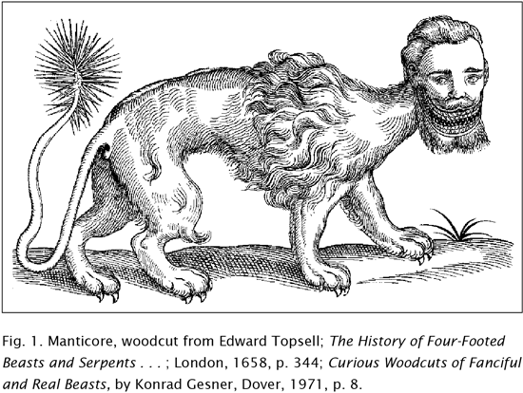
- Any other type of illustrative visual material—a photograph, map, line drawing, graph, or chart—should be labeled Figure (usually abbreviated Fig.), assigned an arabic numeral, and given a caption.
- A label and caption ordinarily appear directly below the illustration and have the same one-inch margins as the text of the paper.
- If the caption of a table or illustration provides complete information about the source and the source is not cited in the text, no entry for the source in the works-cited list is necessary.

Notes (centered)
- Endnotes begins on a new page after the paper but before the Works Cited.
- Double-space all entries and indent each entry by 0.5” from the margin.

Appendix
- The appendix appears before works cited in MLA 8th formatting.
- If you have more than one appendix, name the first one Appendix A, the second one Appendix B and so on.
- The appendices would appear in the order that you mention them in your essay and each appendix appears on a new page.

Works Cited
- List of all the sources used in the entire paper.
- MLA now requires only the publisher and not the city of publication. It also does not require sources to have a publication marker (such as “print”).
- If a source had three or more authors, only the first one shown in the source is given and followed by et al.

