The University of Texas at Tyler
UT Share / PeopleSoft Workflow
Travel Authorization Procedures for
“Reports To” Supervisor and “Budget Authority” Approver
Financial Services highly recommends that you choose Chrome as your browser for entry, certification and approval in UT Share/PeopleSoft.

In general the electronic Travel Authorization (TA) workflow path is as follows:
- TA is created by a department administrative assistant or other support staff.
- TA routes forward to the employee’s “Reports To” supervisor as per the official HR assignment.
- TA routes forward to one or more Budget Authorities depending on funding.

Pending Travel Authorizations may be accessed in one of two ways:

- Approver will be notified by email.

Once the Travel Authorization has been submitted by the creator, the approver will receive a notification email similar to the following.

Note: The email address that is on file with Human Resources is used to generate the email notification.

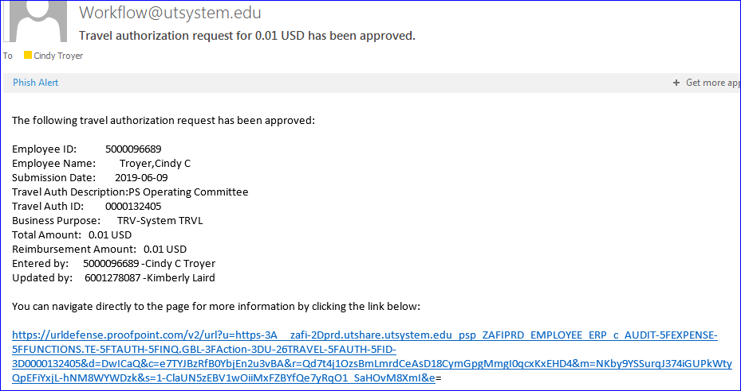

Click on the blue hyperlink at the bottom of the email to navigate directly to the Travel Authorization document.
Enter your entire email address and university single sign-on password if you are not already logged in.

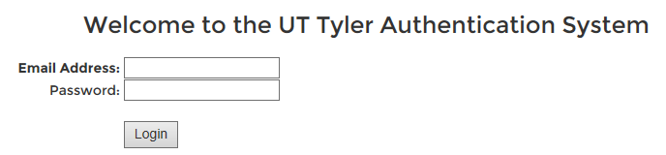

- Or, if you deleted or cannot find the email notification, you may also login directly to UT Share / PeopleSoft using the university single sign-on user ID and password.

After you have logged in, you will be directed to the UT Share/PeopleSoft Home screen and then may click on the “Worklist” hyperlink found in the upper right corner of UT Share/PeopleSoft web page.

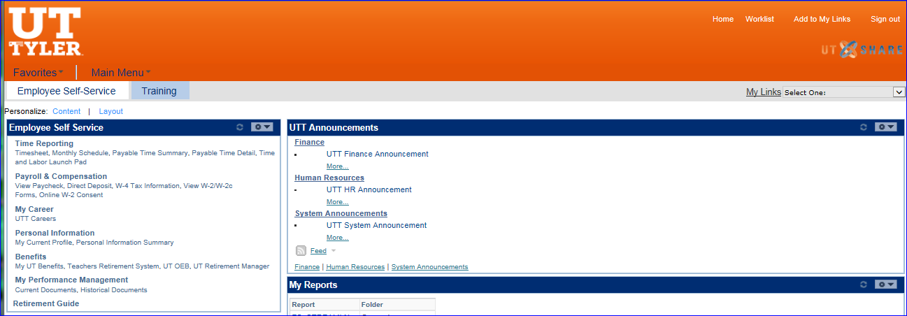

If you have any documents pending your approval the Worklist screen will populate similar to the below example. Click on the hyperlink beside your employee’s name for the TA which requires approval.

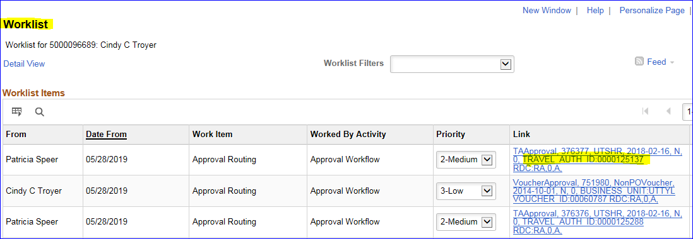

The Travel Authorization document will populate your computer screen.
Travel Authorization document review:

Review the trip information in the Summary section to determine whether it is appropriate for your employee to be away during the time frame indicated on the document and also to determine whether the trip is appropriate business travel in accordance with university policy.

For Reports To Supervisors only (i.e. you are not the department budget authority), Review the trip information to make the determination whether to Approve or not Approve the employee’s trip. (See instructions for the document actions below).

Additional Budget Authority Review:
A Budget Authority must also review the document detail and estimate for anticipated expenses and assigned fund source prior to approving.

Review the Attachments and Notes section.

You may need to click the arrow to the left of the Attachments and Notes label to expand the section for review.

By scrolling over the box for Attachments and Notes, the whole box becomes a “button”.
Click anywhere in the box to access the Attachments popup window.

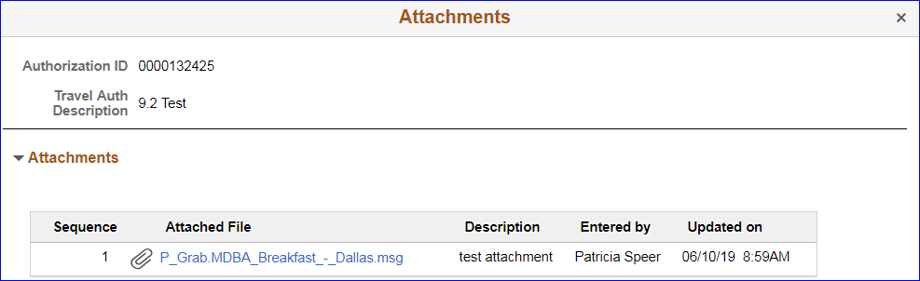

Open and review each attachment for the trip cost estimate or for appropriateness of the requested trip.

Close the popup window by clicking on the “X” in the top right corner of the window.
Back on the Travel Authorization home screen review the transaction Lines section. You may need to click the arrow to the left of the Lines label to expand the section for review.

By scrolling over the box for each Date/Expense Type, the whole box becomes a “button”. Click anywhere in the box to access the Date/Expense Type popup window.

On the Approval Line Detail screen review the Line Detail and then click anywhere in the box labeled View Accounting to access the Chart Field funding information.

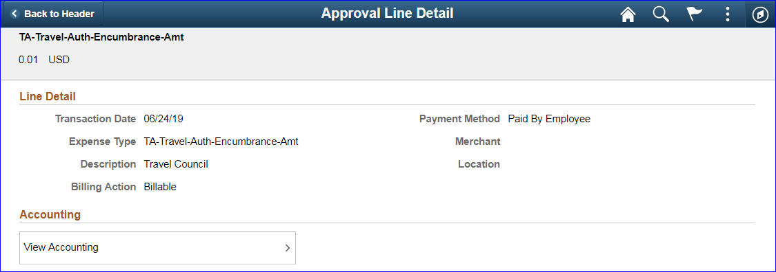

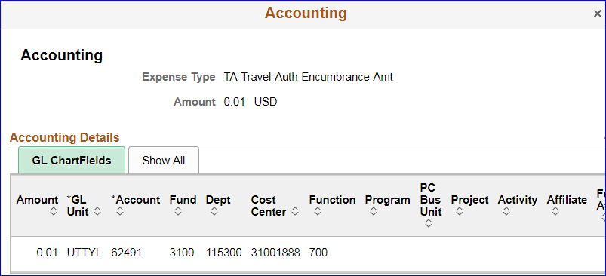

A popup window labeled Accounting will result. Review the chart field data for appropriateness – Is this where you want the expense paid from? If the funding is not correct, you will need to send the Travel Authorization back to the creator.

Click the “X” to close the popup window for the Accounting information.

From the Approval Line Detail screen, click the Back to Header button in the top left corner to return to the Travel Authorization home screen.

The Approver Comments section is found at the bottom left corner of the Travel Authorization screen.

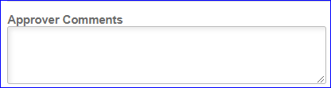
Note: Any action other than approval of the document will require that comments be entered in the Approver Comments section of the document. In addition, you may also optionally enter comments when you are approving the document prior to clicking the Approve button.

Below the Approver Comments section is the Approval Chain section.

Click anywhere in the box to access the Approver Chain popup window.

The Approver Chain section shows who has already Approved, taken action and/or written Comments about the Travel Authorization.

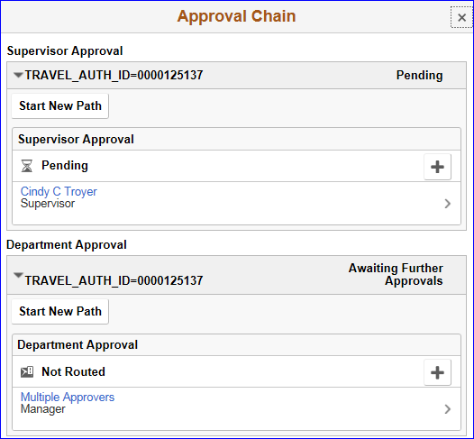
Click the “X” to close the popup window for the Approver Chain information.

Approvers in the workflow routing path may not make any changes to a Travel Authorization. If changes or corrections must be made to the Travel Authorization, the document must be Sent Back to the document creator.

Approvers have four actions to choose from when reviewing a Travel Authorization.

In the top right corner of the Travel Authorization page, the Approve and Terminate buttons are located.

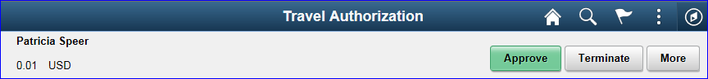

Click the More button to see the other two action options.

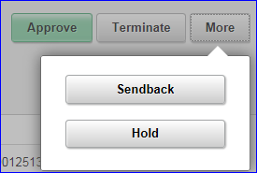

- Approve: Document is approved and routed to the next workflow approver.
- Sendback: Document is sent back to the creator for changes or corrections from any workflow approver in the routing path. Action requires a Comment. Documents sent back generate an email for the creator.
- Terminate: Travel is not approved and the Travel Authorization is removed from workflow entirely. Action requires a Comment.
- Hold: Document is placed on Hold by the approver pending further review. The approver must take the document off Hold to move the document forward or back.

Clicking any of the action buttons navigates the Approver to a confirmation screen.

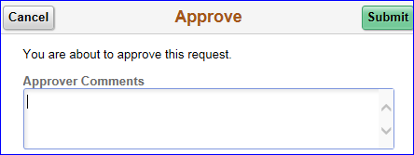 | 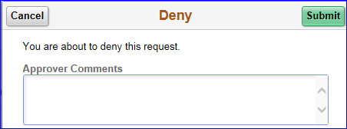
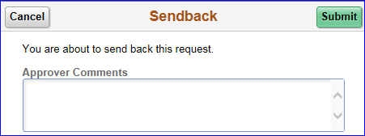 | 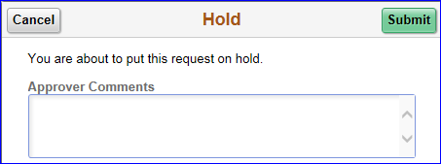

Click the Submit button to proceed with the action or click the Cancel button to return to the Travel Authorization screen for further review or to click a different action button.

Note: You may add Comments prior to clicking Submit for any of the actions.

Note: An employee Supervisor who is also the Budget Authority for the document will only be required to electronically approve the Travel Authorization one time.

You may briefly see a notification highlighted across the top of the screen such as the below example.

If so, the highlighted bar will quickly disappear resulting in the Travel Authorization screen.

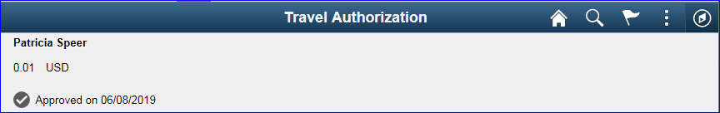

Both the notification and the updated Travel Authorization screen will indicate that the document is in “Approvals in Process or Approved” status until it has been final approved.

Please note: If a Travel Authorization is funded with Grant funds, the Travel Authorization will route to the Grants Central Office for review and approval.

To return to the document Worklist, first click on the Home icon at the top right corner of the screen, then click on the Worklist hyperlink.

