The University of Texas at Tyler
UT Share / PeopleSoft
Expense Reimbursement Procedures for
Budget Authority or Other Approver
Financial Services highly recommends that you choose Chrome as your browser for entry, certification and approval in UT Share/PeopleSoft.

In general the electronic Expense Report (ER) workflow path is as follows:
- ER is created by a department administrative assistant or other support staff.
- ER routes forward to the employee for Employee Certification of expenses.
- ER routes forward to one or more Budget Authorities depending on funding.
- ER routes forward to Grants Central Office if grant funding is assigned.
- ER routes forward to Disbursements & Travel for final review and approval.

Please note that a Budget Authority may not approve his/her own Expense Report. The Expense Report must route to his/her HR assigned “Reports To” Supervisor.

Pending Expense Reports may be accessed in one of two ways:

- The Approver will be notified by email.

Once the Expense Report has been certified by the employee, the Budget Authority or other approver will receive a notification email similar to the following.

Note: The email address that is on file with Human Resources is used to generate the email notification.

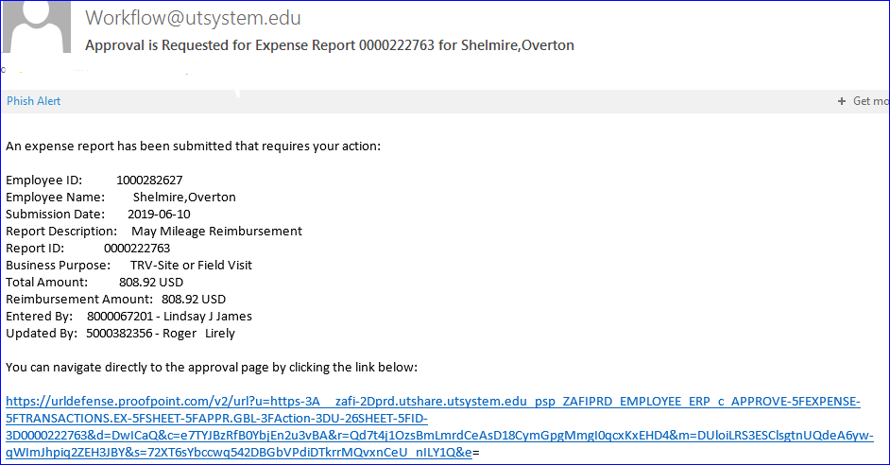

Click on the blue hyperlink at the bottom of the email to navigate directly to the Expense Report.

Enter your entire email address and university single sign-on password if you are not already logged into UT Share/PeopleSoft.

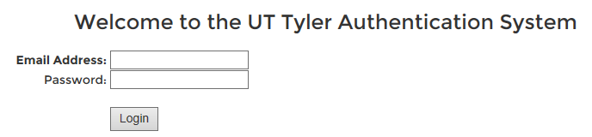

- Or, if you deleted or cannot find the email notification, you may also login directly to UT Share / PeopleSoft using the university single sign-on user ID and password. After you have logged in, you will be directed to the UT Share/PeopleSoft Home screen and then may click on the Worklist hyperlink in the upper right corner of UT Share/PeopleSoft web page.

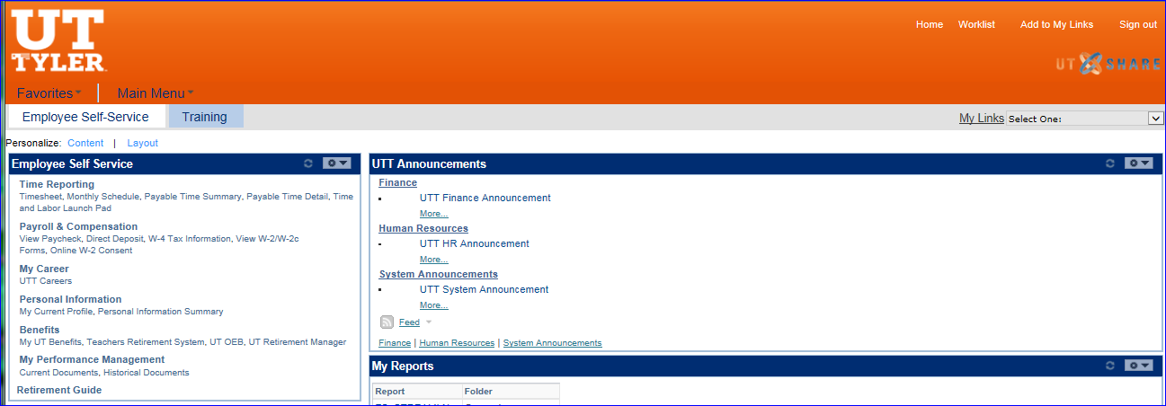

If you have any documents pending your approval the Worklist screen will populate similar to the below example.

Click on the hyperlink for the Expense Report you wish to review and approve.

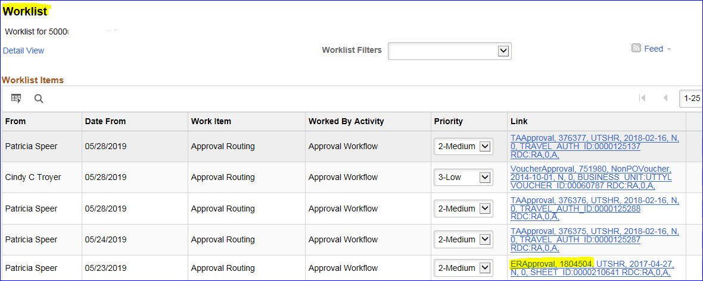

The Expense Report document will populate on your computer screen.

Expense Report review:
Review the trip information and Total Due Employee in the Summary section.
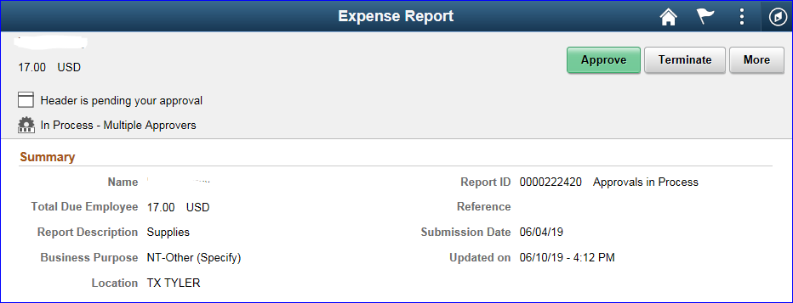

Review the Attachments and Notes section. All Expense Reports are required to have transaction supporting documentation attached.

You may need to click the arrow to the left of the Attachments and Notes label to expand the section for review.

By scrolling over the box for either View Attachments or View Notes, the whole box becomes a “button”.

Click anywhere in the View Attachments box to access the Attachments popup window.

Open and review each attachment listed to review receipts for appropriateness, accuracy, and compliance.
Close the popup window by clicking on the “X” in the top right corner of the window.

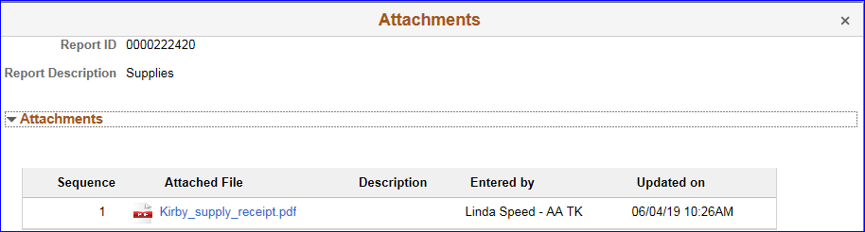

Click anywhere in the View Notes box to access and review the Notes popup window.

Close the popup window by clicking on the “X” in the top right corner of the window

Back on the Expense Report home screen review the transaction Lines section. You may need to click the arrow to the left of the Lines label to expand the section for review.

By scrolling over the box for Date/Expense Type, the whole box becomes a “button”.

Click anywhere in the Date/Expense Type box to access and review the Approval Line Detail screen.

The Approval Line Detail screen shows more information about that particular expense line.

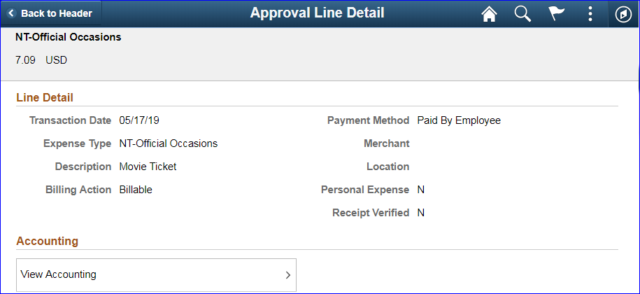

To review the chart field funding information, scroll over the box labeled View Accounting.

Click anywhere in the View Accounting box to access and review the Accounting Detail screen.

A popup window labeled Accounting will result. Review the chart field data for appropriateness – Is this where you want the expense paid from? If the funding is not correct, you will need to send the Voucher back to the creator.

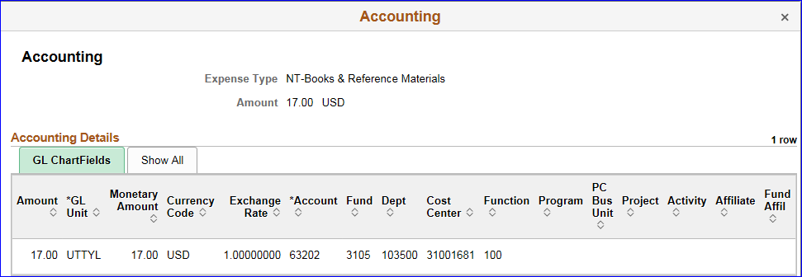

Click the “X” in the top right corner to close the popup for the Accounting information.
When you have finished reviewing the line detail screen for this line, click the Back to Header button found in the top left corner of the Approval Line Detail label line.

The Approver Comments section is found at the bottom left corner of the Expense Report screen.

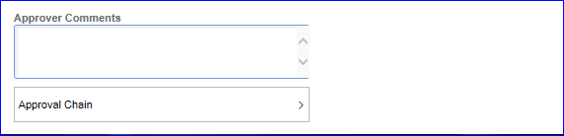

When taking the action to Approve an Expense Report, the Comments section is optional. All other actions require that Comments be added.

Below the Approver Comments is an Approval Chain section.

Scroll over the box labeled Approval Chain and click anywhere in the box to access and review the approval information.

The Approver Chain section shows who has already Approved, taken action and/or written Comments about the Expense Report

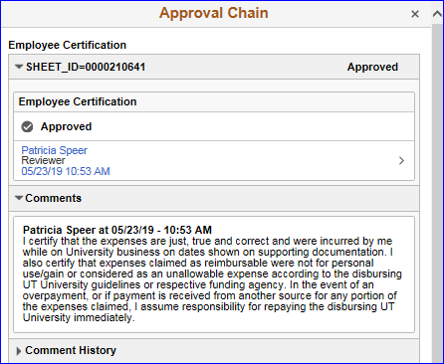 | 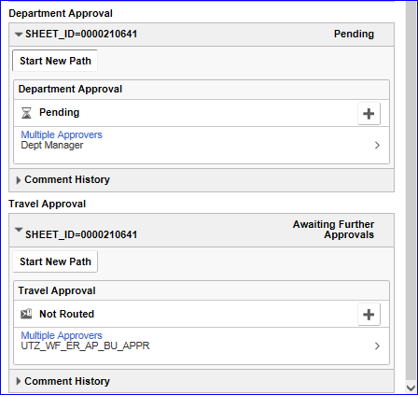

Budget Authorities may not make any changes to an Expense Report. If changes or corrections must be made to the Expense Report, the document must be Sent Back to the document creator.

Budget Authorities or other Approvers have four actions to choose from when reviewing an Expense Report.

In the top right corner of the Expense Report page, the Approve and Terminate buttons are located.

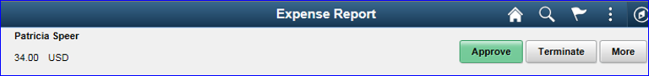

Click the More button to see the other two action options.

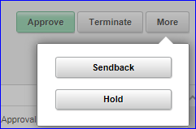

- Approve: Document is approved and routed to the next workflow approver.
- Sendback: Document is sent back to the creator for changes or corrections from any workflow approver in the routing path. Action requires a Comment. Documents sent back generate an email for the creator.
- Terminate: Reimbursement is not approved and the Expense Report is removed from workflow entirely. Action requires a Comment.
- Hold: Document is placed on Hold by the approver pending further review. The approver must take the document off Hold to move the document forward or back.
Clicking any of the action buttons navigates the Budget Authority or other approver to a confirmation screen.

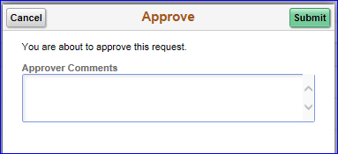 | 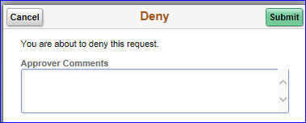
 | 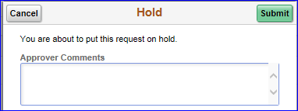

Click the Submit button to proceed with the action or click the Cancel button to return to the Expense Report screen for further review or to click a different action button.

Note: You may add Comments at this step prior to clicking Submit for any of the actions.

You may briefly see a notification highlighted by a green bar across the top of the screen such as the below example.
If so, the green bar will quickly disappear resulting in the Expense Report screen.

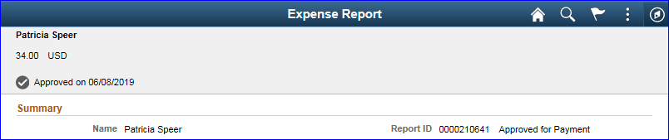

Both the notification and the updated Expense Report screen will indicate that the document is in “Approvals in Process” status until it has been final approved by the Disbursements and Travel team.

Please note: If the Expense Report is funded with Grant funds, the Expense Report will route to the Grants Central Office for review and approval. All Expense Reports route to the Disbursements and Travel Office for review and final approval.

To return to the document Worklist, first click on the Home icon at the top right corner of the screen, then click on the Worklist hyperlink in the top left corner.

