The University of Texas at Tyler
Procedures for Entering Blanket POs in PeopleSoft
Please follow the navigation directions, and initial steps found on the “Create Requisition” procedures until you get to the following step:

On requisition, Checkout – Review and Submit page:
- Click the Line Details icon at the end of the line you want to pay as ‘Amount Only’.
- It will take you to the next screen, ‘Line Details’.
- Check the Amount Only box and click OK.
- The screen returns to the Checkout - Review and Submit page.
- Add a comment to the box at the bottom of the Checkout - Review and Submit page and check the box for ‘Shown at Voucher’.
- Proceed with your requisition as normal (see the Create Requisition procedures).
CLICK THE LINE DETAILS ICON AT THE END OF THE LINE.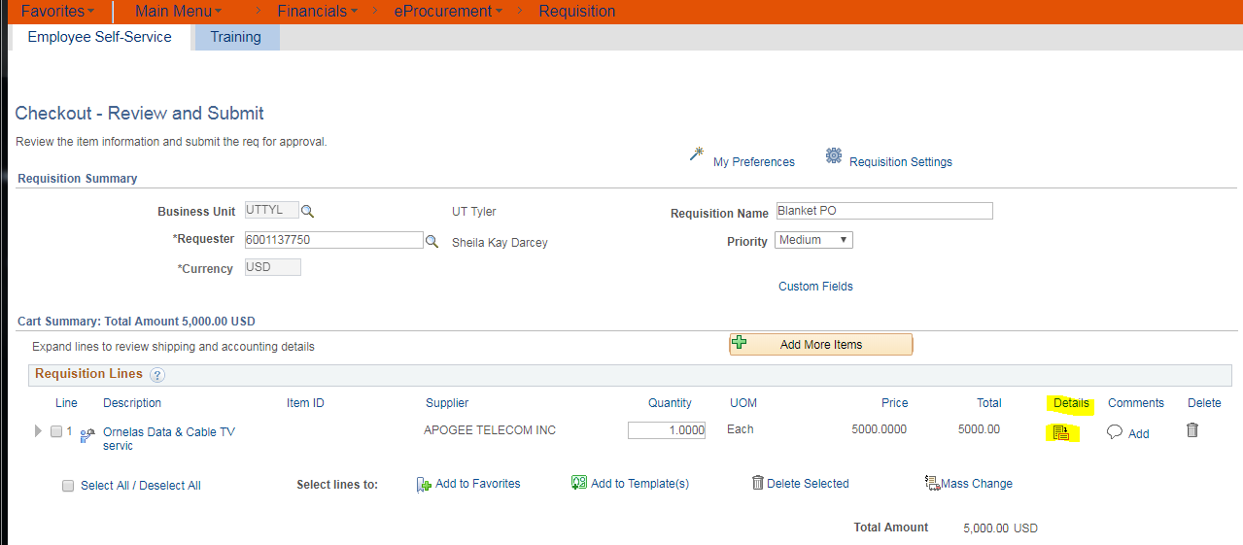
NEXT SCREEN, CHECK THE AMOUNT ONLY BOX AND CLICK OK.
