PO Voucher Entry
Note: Follow navigation procedures found in the Create Non-PO Voucher entry procedures.
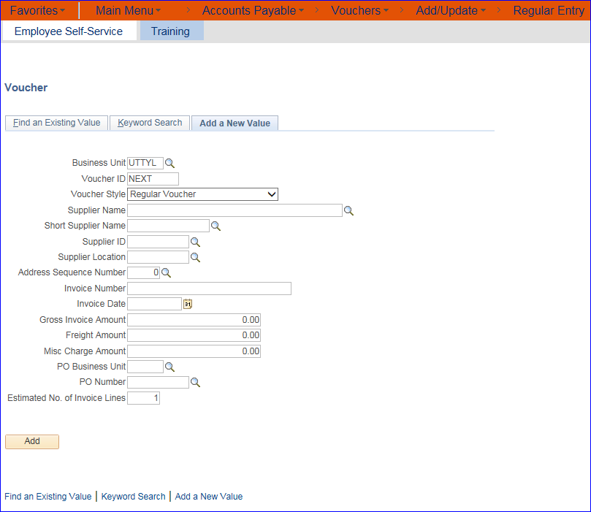
The 9.2 upgrade version of UT Share/PeopleSoft has an option to pull in the Purchase Order from the initial Voucher data entry screen.
ONLY use this PO Voucher option if you are paying for a purchase order in full.
Do not use this option for a partial payment.

On the initial Voucher entry screen, begin by entering a part of the Supplier Name or Short Supplier Name then click the search icon. Select the correct Supplier for your payment.
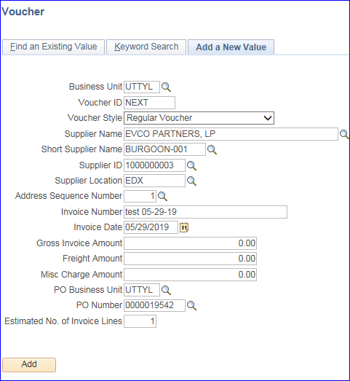
The Supplier ID, Supplier Location, and Address Sequence Number for the Purchase Order will auto-populate the screen.
Enter the Invoice Number exactly as shown on the Supplier Invoice form.
Enter the Invoice Date as pre-printed on the Supplier Invoice. Note: This may NOT be the same date that you physically received the Invoice either by U.S. mail or by email.
Do not enter any amounts in the Gross Invoice Amount, Freight Amount, or Misc Charge Amount fields.
When paying in full for the purchase order ONLY, at the PO Business Unit field, click the search icon and select UTTYL. You will be returned to the Voucher entry screen.
When paying in full for the purchase order ONLY, at the PO Number field, click the search icon then select the PO Number from the list that pops up.
For a PO Voucher do not change or add any number of lines in the Estimated No. of Invoice Lines field.
Click the ADD button to create the PO Voucher.

You will be directed to the Invoice Information tab screen of the new voucher.
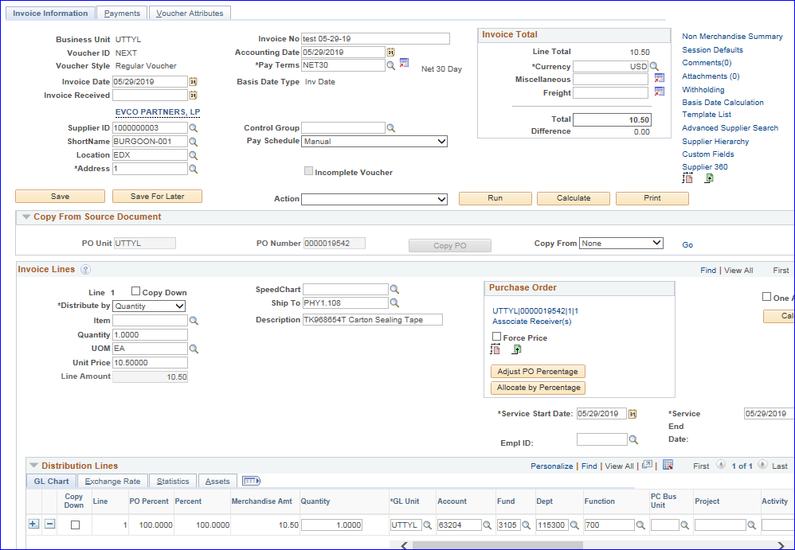
The Copy From Source Document section, shows the PO Business Unit and PO Number.

When NOT paying a purchase order in full or if you prefer the original method, complete the Voucher entry screen as above:
The Supplier ID, Supplier Location, and Address Sequence Number for the Purchase Order will auto-populate the screen.
Enter the Invoice Number exactly as shown on the Supplier Invoice form.
Enter the Invoice Date as pre-printed on the Supplier Invoice. Note: This may NOT be the same date that you physically received the Invoice either by U.S. mail or by email.
Do not enter any amounts in the Gross Invoice Amount, Freight Amount, or Misc Charge Amount fields.
Leave the PO Business Unit field blank.
Leave the PO Number field blank.
For a PO Voucher do not change or add any number of lines in the Estimated No. of Invoice Lines field.
Click the ADD button to create the PO Voucher.
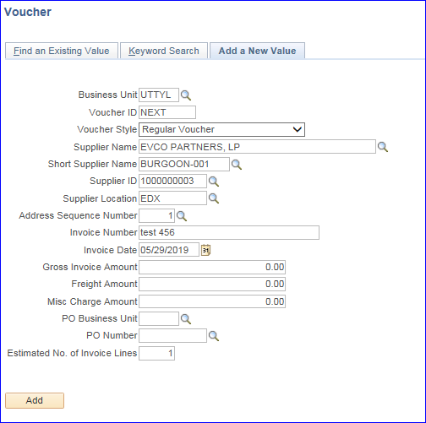

You will be directed to the Invoice Information tab screen of the new voucher.
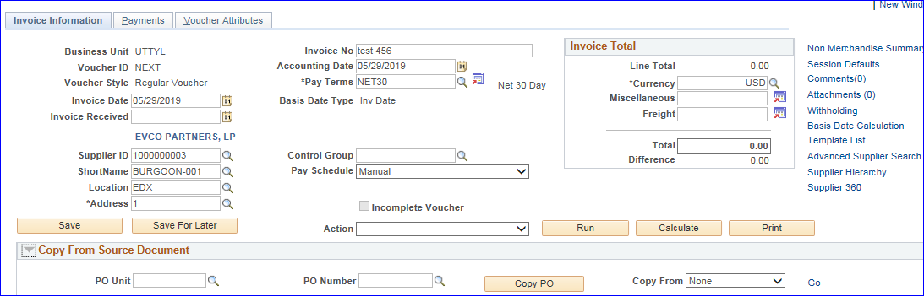
Click the arrow beside the Copy From Source Document label if the section is not already expanded.
On the right side of the Copy From Source Document section click the drop down arrow at the Copy From action box.
Select Purchase Order Only, then click the GO hyperlink.
On the resulting screen, click the search icon for PO Business Unit and select UTTYL.
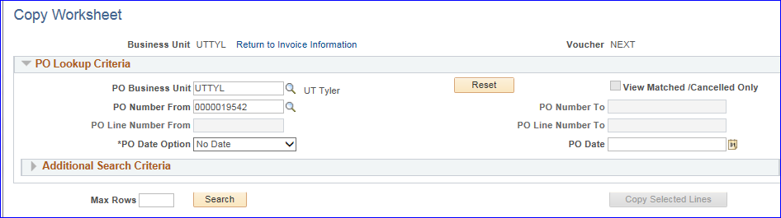
Click the search icon for PO Number From and select your purchase order from the list.
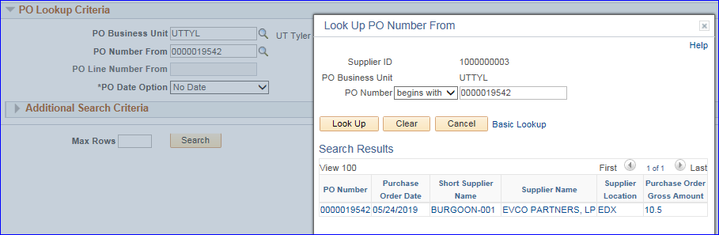

After your purchase order has populated the screen, the scroll down to the Select PO Lines section a click the Select box for each line below that will be paid on this voucher, then click the Copy Select Lines button.
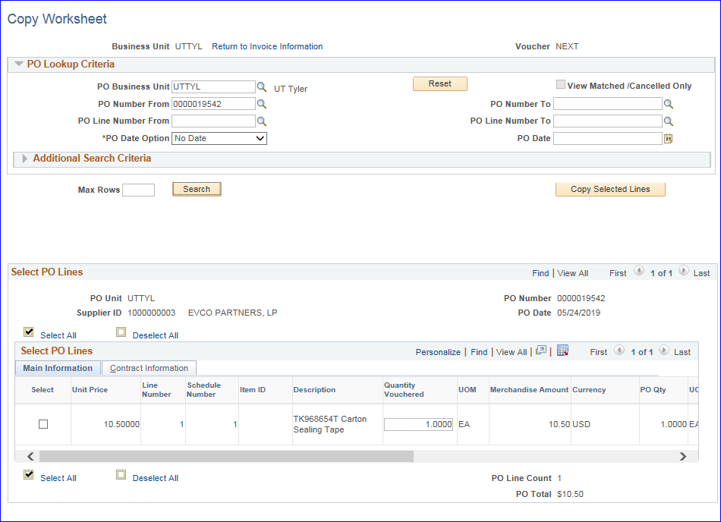

You will be returned to the voucher Invoice Information tab screen.
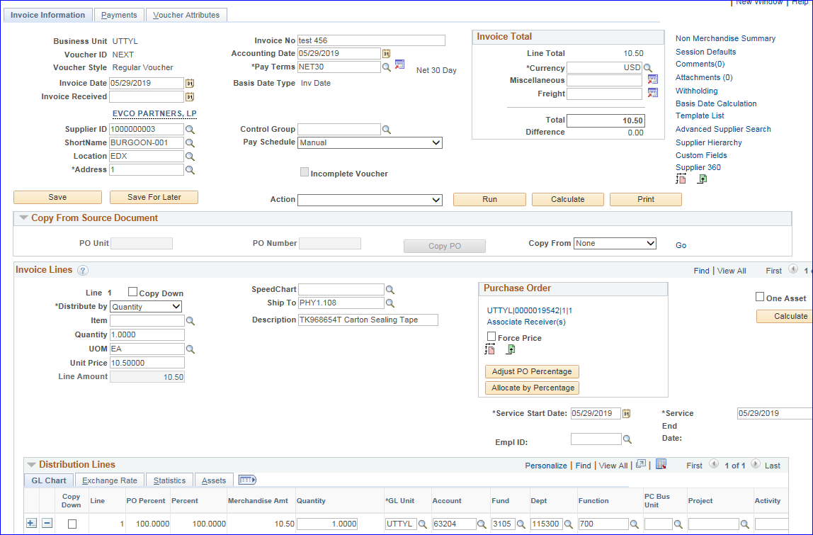
Complete the voucher as previously discussed.
Click on the Save for Later button or Save button depending on how far along you are.
When the PO Voucher has been Saved, the Action dropdown box will show a Matching option.
When you have completely finished the PO Voucher, click on Matching then click on the Run button beside the Action box.
Click on the Summary tab to navigate to that screen to review the Matching status.

A status of Matched is good.
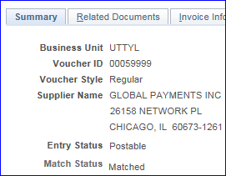
A status of Exceptions needs attention before you may proceed with the voucher.
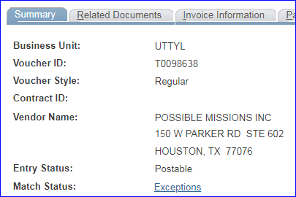
Contact the Procurement team at purchasing@uttyler.edu for assistance in correct Match Exceptions.
Complete the PO Voucher as shown in the Non-PO Voucher procedures.

