Create a My Wallet Expense Report
A My Wallet Expense Report is created for paying travel card charges and any, if applicable, out of pocket travel expenses.
Navigation NavBar >Navigator >Financials >Travel and Expenses>Travel and Expense Center>Expense Report>Create/Modify
OR
From the home screen click on the drop down menu and choose the Travel & Expense landing page then click on the Create Expense Report tile.
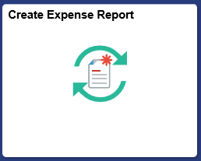
Key in the Empl ID or Search for the name. Click Add
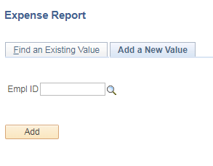
Complete the General Information section as for any Expense Report or pull in the Travel Authorization.
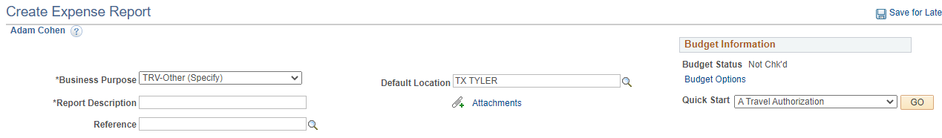

If you did not pull in a Travel Authorization, then you can click on the Quick Start and choose Entries from My Wallet. If you did pull in a TA then you can click on the My Wallet (x).

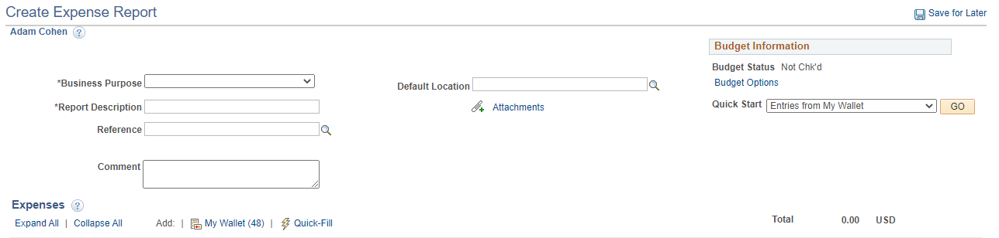

Choose the entries that you want to include in this report by clicking on the Select , then on the Done button.
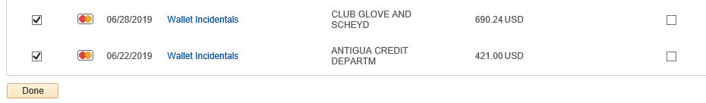

The selected entries are added to the Expense Report.
The stated “Wallet…” Expense Type pulled in with the My Wallet transactions are NOT valid and MUST be changed.
On the transaction information line, click on the drop down and select a valid and correct Expense Type option for each transaction entry.
Enter any Description that is needed.
Enter the Cost Center into the Speed Chart (if the Cost Center has not already populated).
If the entry needs to be Split, such as a hotel bill split into Lodging – Lodging Tax – Parking, then click on the Receipt Split hyperlink.

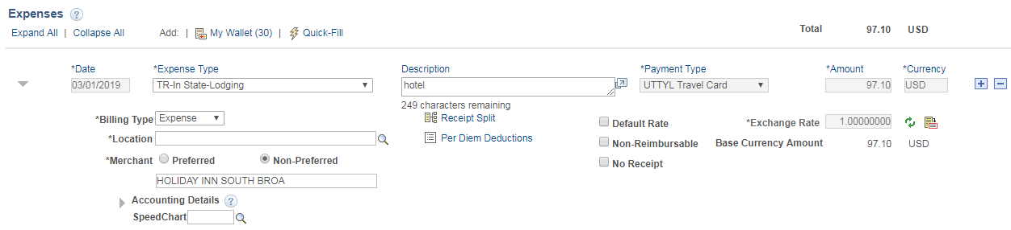

To split an entry -
Under Split With Another Expense (bottom) click on the Expense Type drop down, then choose an additional “TR” type.
Click on the Split button
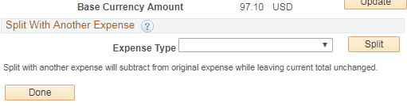

Enter the dollar amount of the new Expense Type in the Amount Spent box. Click on Update.
Repeat as needed.
Click on the Done button.
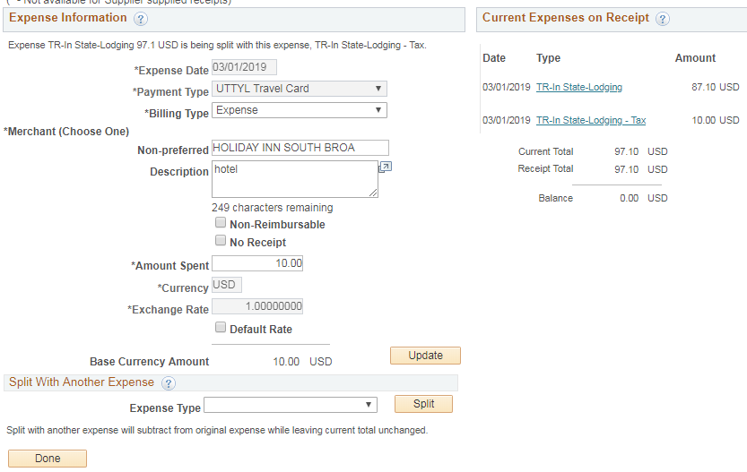

The new split entries will have been added to the report.

To enter more entries from the My Wallet screen, click on the My Wallet hyperlink, then once again, follow instructions found on page 2 that begin with “Under Expense type, click on…”
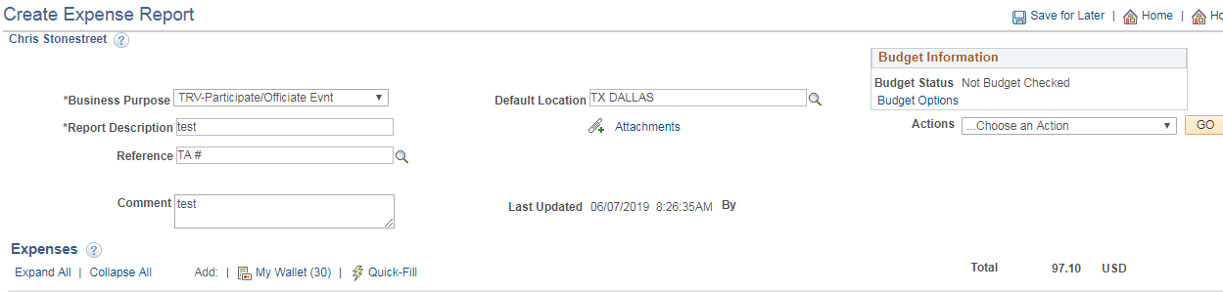

To add out of pocket expenses, click on the plus sign box.

When all entries are complete;
Attach receipts and all back up documentation, Ex. Substation of Business Meeting and Entertainment Expense Form.
Click on the Save For Later hyperlink
Click on the Budget Options hyperlink
Click on the Budget Check then OK
Click on the Summary and Submit hyperlink
Click on the Submit Expense Report button
Click on the OK button

