UT Share/PeopleSoft has been updated effective 05/15/2022. There are no functional changes, however, there are some changes to the way UT Share/PeopleSoft looks and to the way you access screens.
UT System IT recommends using the Chrome internet browser. Before logging in, make sure to clear ALL browsing data for ALL time.
On the home screen, or the Employee Self Service landing page, the title and drop down for Employee Self Service has been moved to the left side of the screen. When the curser is hovering over the words, the button turns white. The dropdown menu operates the same. UT System IT is aware that there is an issue with black text on the dark blue background and is working to correct it.
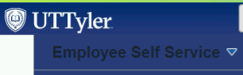
In addition to the Employee Self Service dropdown menu, you may also move between landing pages by clicking on the page forward / backward arrows found at the top right corner of the screen.
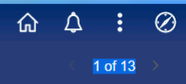
From the top right corner, the Search icon has been removed but the Search feature is now a box at the top middle of the screen.
When you click in the Search in Menu box, the system will display options for which you have security. You may also type a specific search word and then click on the magnifying glass.
The Notifications feature may be fully displayed on the entire right side of your screen when you first log in. Users can toggle between displaying Full Notifications Text and/or limit the number of Actions/Alerts that are visible.
If you do not need the Notifications panel up on the right side of your screen, you can change the settings to hide it and only show the Bell notifications icon instead.
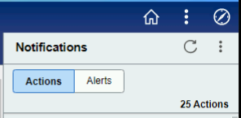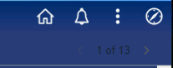
To change the Notifications view setting, click on the three-dot ellipse found on the top right corner of the screen and then click the Personalize Homepage option.
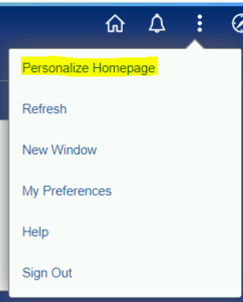
Change the Common Settings for Show Notifications Panel from Yes to No and then click the Save button.
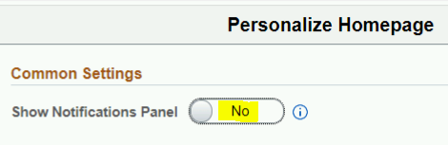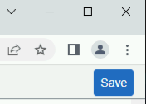
Recently Visited and/or Favorites are still available through the NavBar, however, on the far-left side of the Employee Self Service “home” screen, there is a new feature for Recently Visited screens and your Favorites. The clock icon represents Recently Visited and the heart icon represents your Favorites.
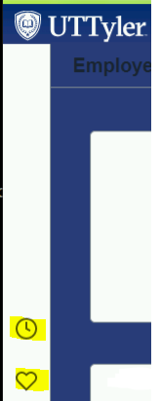

There have also been changes to the NavBar.

Old Titles | New Titles
Recent Places | Recently Visited
My Favorites | Favorites
Navigator | Menu

The below NavBar screenshot is only an example. Yours may have items in a different order.
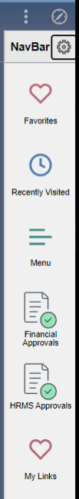 | The NavBar Menu now has an option to alphabetize the list.  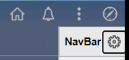  To change from the Standard setting to an Alphabetical setting, click on the Settings “gear” icon next to the title NavBar and in the Personalize drop down, change the Menu Order from Standard to Alphabetical. Then click Save. You can change it back to the Standard listing by following the same steps.  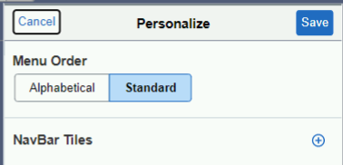
The old Navigator back arrows have been changed to hyperlinked words that will allow you to back up to a specific point or the beginning Menu.
OLD
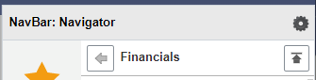
NEW
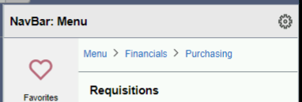

Please be advised that the My Links feature is no longer supported by the software owner, Oracle. The My Links feature is scheduled to be decommissioned later this summer.
If you have navigation quick links that you use in My Links, you can easily set up a My Favorites quick link by first clicking on the quick link found in My Links and once you’ve been directed to that specific screen, click on the three-dot ellipse in the top right corner and select the Add To Favorites option from the drop-down menu. You can use the default label in the pop-up box or type in your own label. Then click the Add option to the right of the pop-up box to complete the action.
