Navigation
- Main Menu > eProcurement > Receive Items
- Click the Add New Receipt link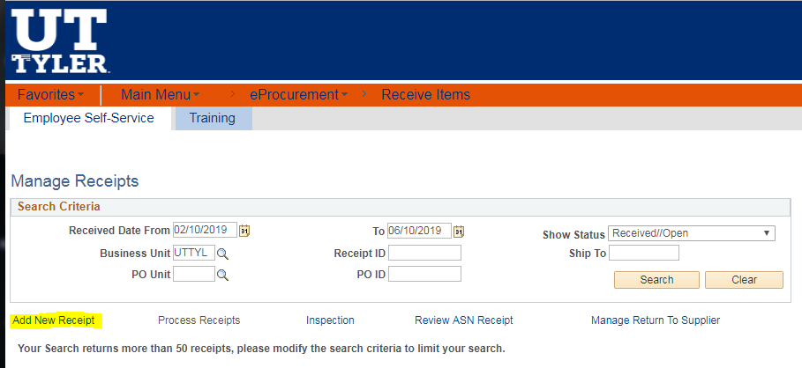
- Verify that Add a New Value is the selected tab
- Click the Add button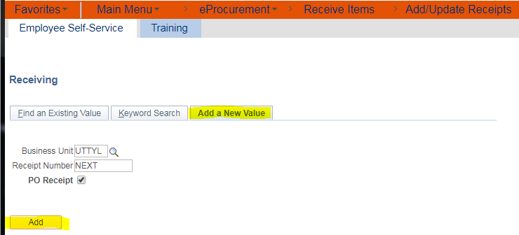

- Click in the ID field
- Enter the desired PO number into the ID field. Enter a valid value e.g. “0000020747”.
- Click Search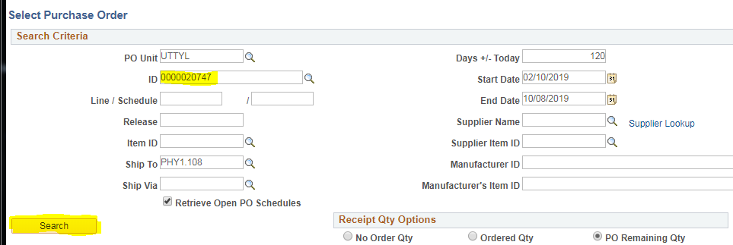
- Check the Select box for each line to be received or Select All to receive entire PO.
- Click the OK button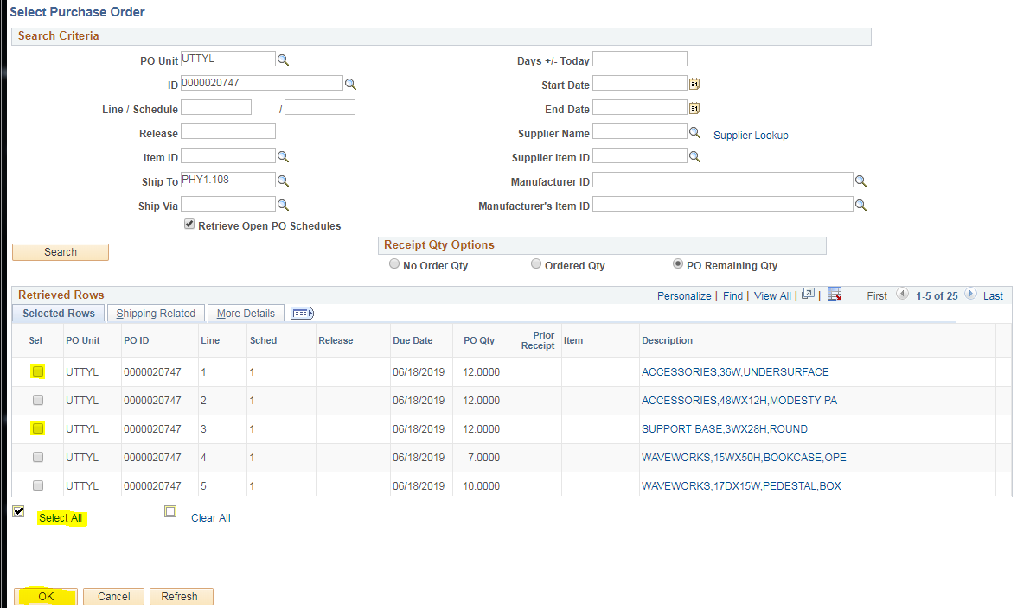

- Verify the Receipt Quantity and change if necessary.
- Click the Save button.
- Verify that the Receipt Status is correct. 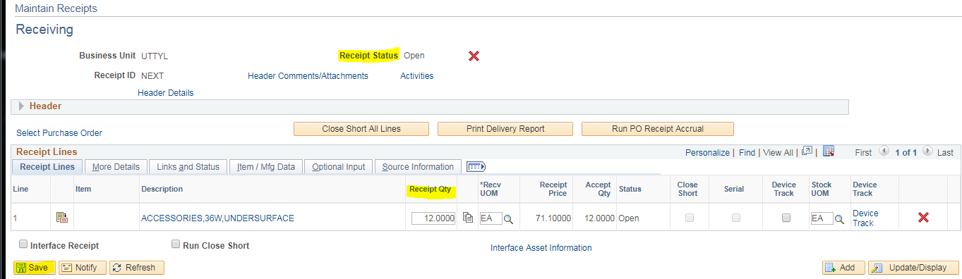
- End of Procedure

