eSHOP for Shoppers Training Manual

Table of Contents
Overview 2
Accessing eSHOP 2
Navigation 3
Creating a Cart 4
Ordering from a Punch-Out Catalog 5
Ordering from a Hosted Catalog 6
Co-Mingled Carts 6
Completing a Cart 7
Multiple Vendor Carts - Deleting More Than One ……………………………………………………………………………….7
Assigning a Cart 11
Editing a Cart 13
Hosted vs. Punch-Out 13
Carts that have been returned to UT Share/PeopleSoft 13
eSHOP Invoices 14
Document Search 14

Overview
eSHOP is a role based shopping tool that allows shoppers to take advantage of pre-negotiated contracts from well-known suppliers. Shoppers are able to search and shop the sight for goods, knowing these have been pre-approved for the University. A Shopper is anyone on campus that does not have security access to create a Requisition in UT Share/PeopleSoft.

Accessing eSHOP
- Navigate to your UT Tyler eSHOP Sign on.
- Enter Network ID and Password
- Click the Login button

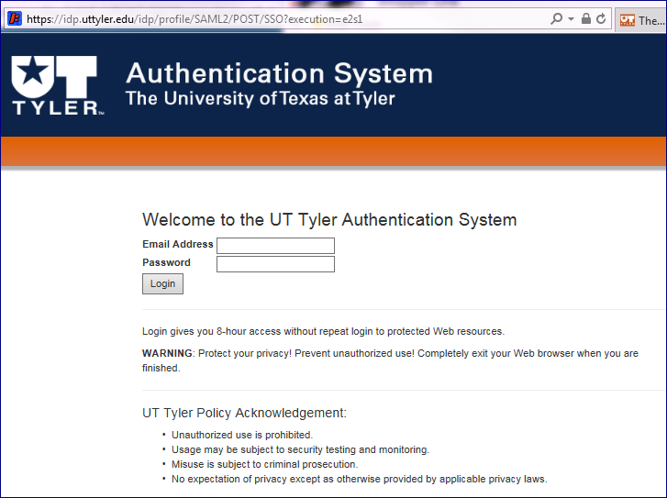

- Begin creating a shopping cart

Navigation

There are three main areas of the eSHOP screen:

- The Main Workspace - The main workspace is where one can manage the active eSHOP feature. It will always display breadcrumbs that tell the navigation path to the page the user is accessing.

- The Side Navigation Menu - Most areas of eSHOP can be accessed from the side navigation menu. When a user rolls over the main menu icons, slide‐out sub‐menus display. In general, menus are grouped by related tasks. For example, shopping tasks are grouped in the Shop menu.

- The Top Banner - The top banner contains access points to the user profile, bookmarks, assigned actions items and available notifications. In addition, users can access a quick view of their active shopping cart and perform a quick search of the site.

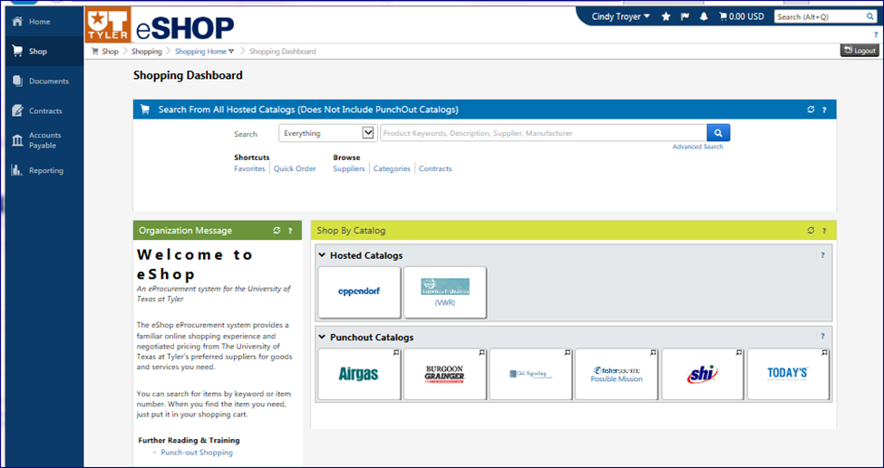

Creating a Cart
There are two ways to shop in eSHOP:
- Punch-Out Catalog: A Punch-Out is a website where the shopper is redirected to the supplier’s site. A cart is created on that site. Then the shopper is redirected back to eSHOP with their selected merchandise.
- Hosted Catalog: A Hosted Catalog is a supplier catalog that is embedded in eSHOP. The catalog is hosted by eSHOP, and can be searched by various criteria. Users can search for an item across all hosted suppliers, allowing users to comparison shop.

When comparative shopping your results will come from among Hosted catalogs, not Punch-Outs.
Users will create a cart in eSHOP using one of these methods. They can have multiple carts in process at the same time. To access your carts, click on the Shop menu, from the slide out menu select My Carts and Orders, and click View Draft Shopping Carts.
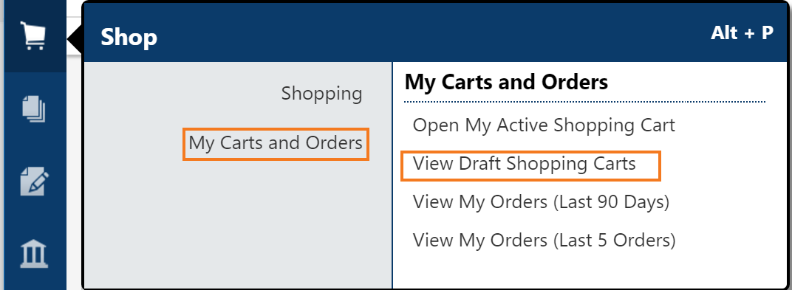
To create a new cart, click on the “create cart” button or simply start choosing items when searching and they will be added to an active cart that will show a summary in your top banner.
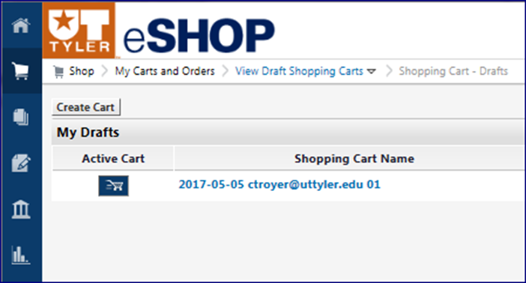
It is very important to remember to select from one vendor catalog at a time and complete the process entirely with that vendor.
Since a cart may eventually become a UT Tyler requisition and purchase order, the rule to remember is One Vendor – One Cart – One Requisition. *

Ordering from a Punch-Out Catalog
Punch-Out catalogs are external links to a supplier’s website. Click on the Vendor Icon in the Punch-Out Catalog section of the Shopping Dashboard. This will take you to the vendor’s website for UT System.

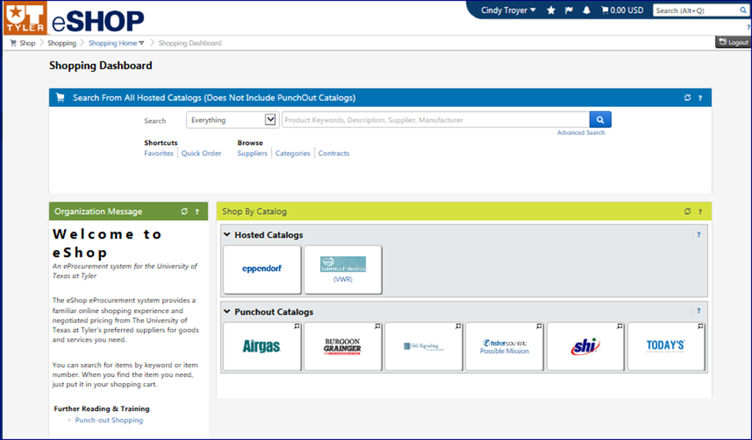

Note: Each vendor’s website will be specific to that vendor. Follow the directions on each website to search, select and order products. Each vendor will have some form of checkout that enables users to return to eSHOP. The Shopping Cart Page will appear when you return to eSHOP.

Ordering from a Hosted Catalog
- Search for items in the hosted catalog by using the simple search displayed below or by clicking on the advanced search.

Example: Battery 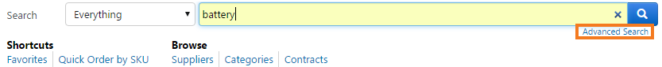
Search results can be sorted by price, supplier, part number, etc. Choose the sort method using the Sort by dropdown. Users can also filter results by keyword, product flag, supplier, category, packaging, etc. 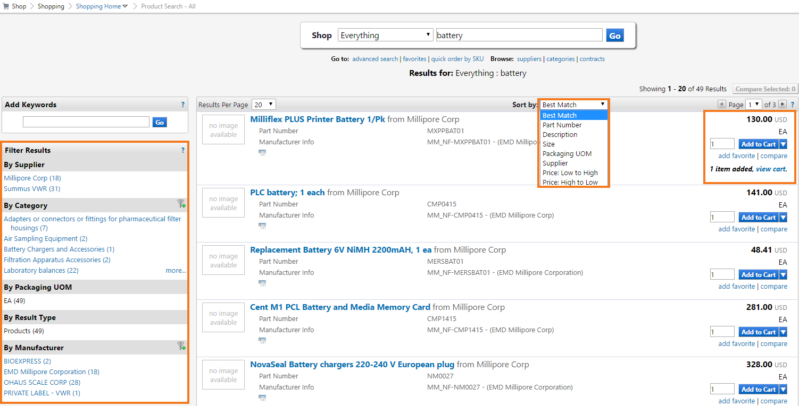
- Change the quantity if needed.
- Click the Add to Cart button.
- Click View Cart to proceed.

Co-Mingled Carts

While eSHOP does allow you to enter items from more than one vendor supplier in the same cart, a co-mingled cart cannot be processed into a Requisition.

Completing a Cart

Once a Shopper has completed shopping and are viewing their cart, they can name the cart for future reference or future searches. A Shopper can also modify the cart, empty the cart or provide various other actions by using the dropdown. If you make changes, click Save button.

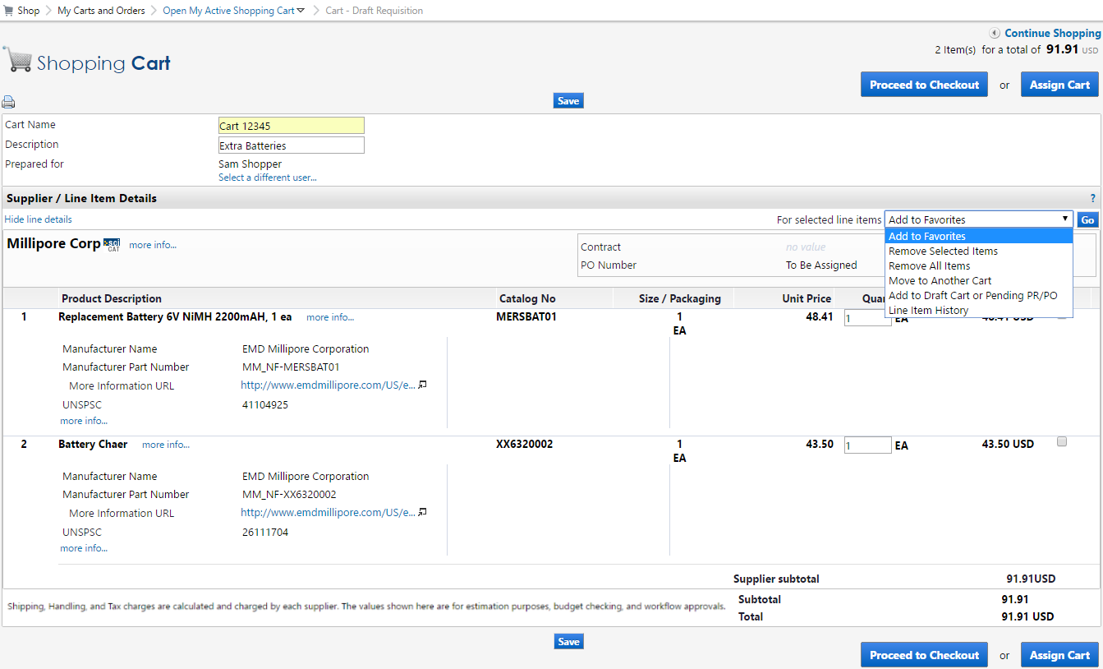

Multiple Vendor Carts – Deleting more than one
*Remember the rule from page 4 - One Vendor – One Cart – One Requisition?
If you inadvertently did select from more than one vendor during your shopping experience and before processing your cart through to assigning it to a Requester, you can fix the problem by deleting all but ONE vendor from your unprocessed cart.

Before assigning your cart to your Requestor, first verify that you only have one vendors goods in your unprocessed cart. Click on the Cart icon in the Top Banner of the screen and then the View My Cart button.
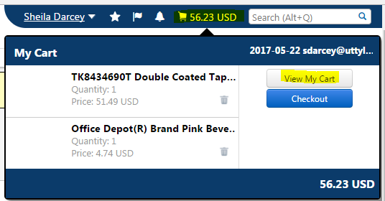
Review the cart list. If there is more than one vendor listed in the cart all but one must be deleted before proceeding.
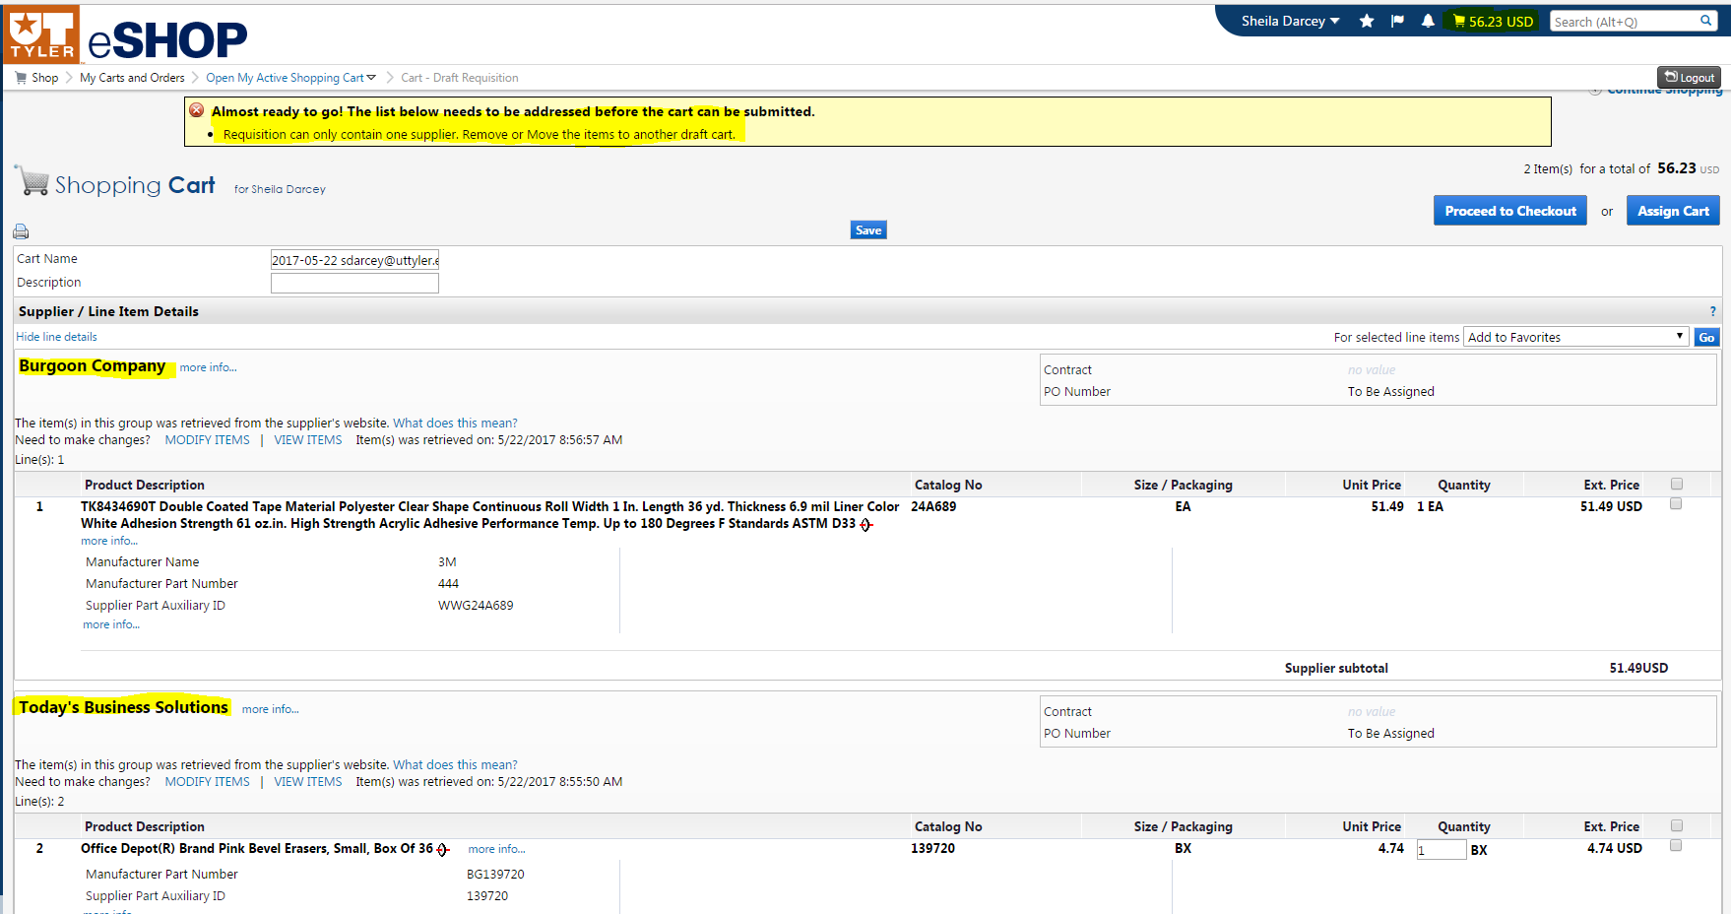

- Select the vendor you want to delete by clicking on the check box on the right-side.
- Select Remove Selected Items from the drop down box.
- Select Go.
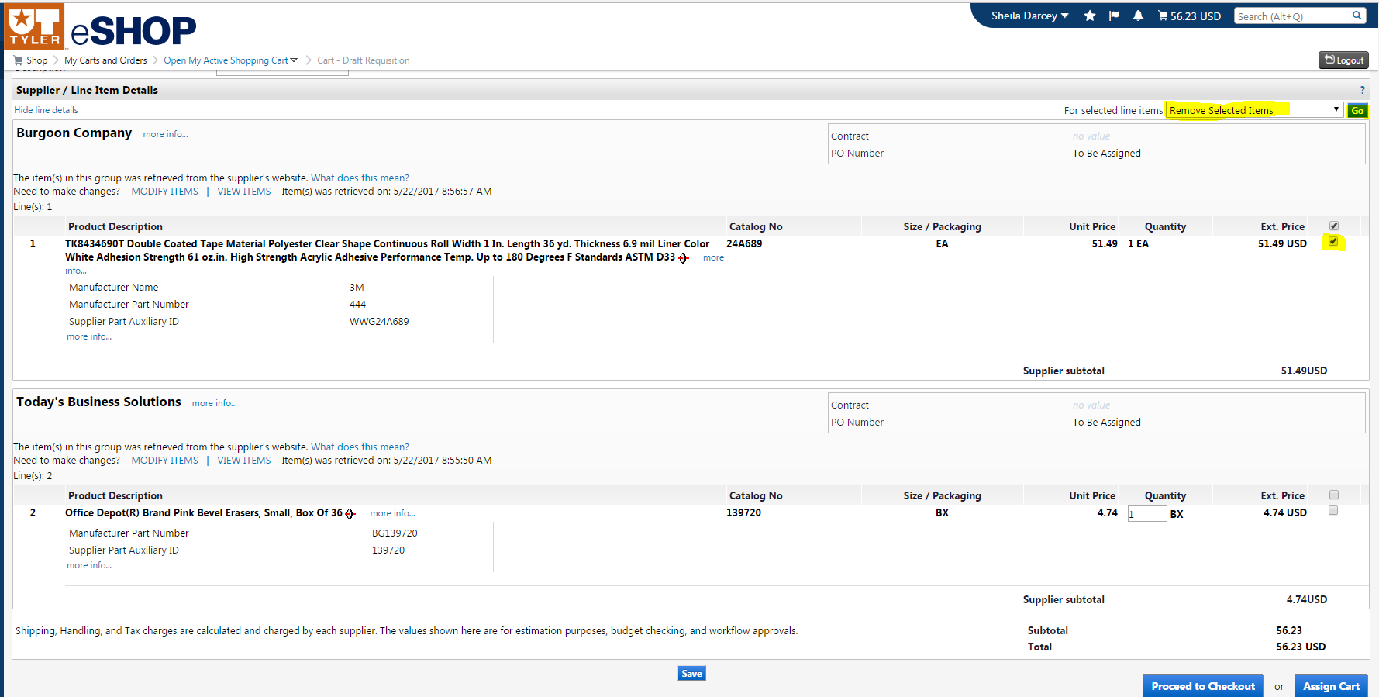
- Proceed with clicking the Assign Cart button.
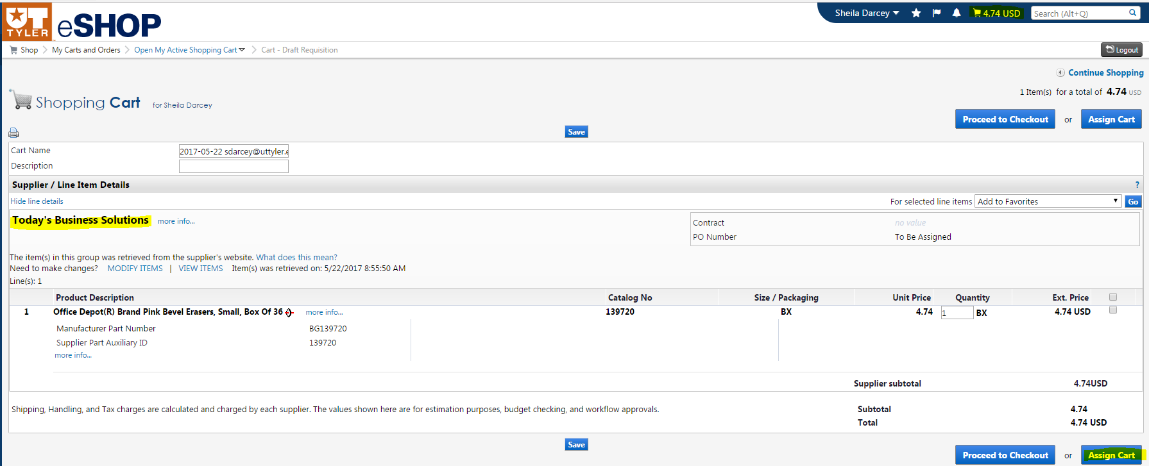

Please note that a cart may not be split into two or more carts.
The software does not support more than One Vendor – One Cart – One Requisition.

While the dropdown box does include an option to “Move to Another Cart” attempts to use it will result in the error messages shown in the screen shot below.

If there are multiple vendors in the cart follow the directions above and delete all but one vendor from the cart.
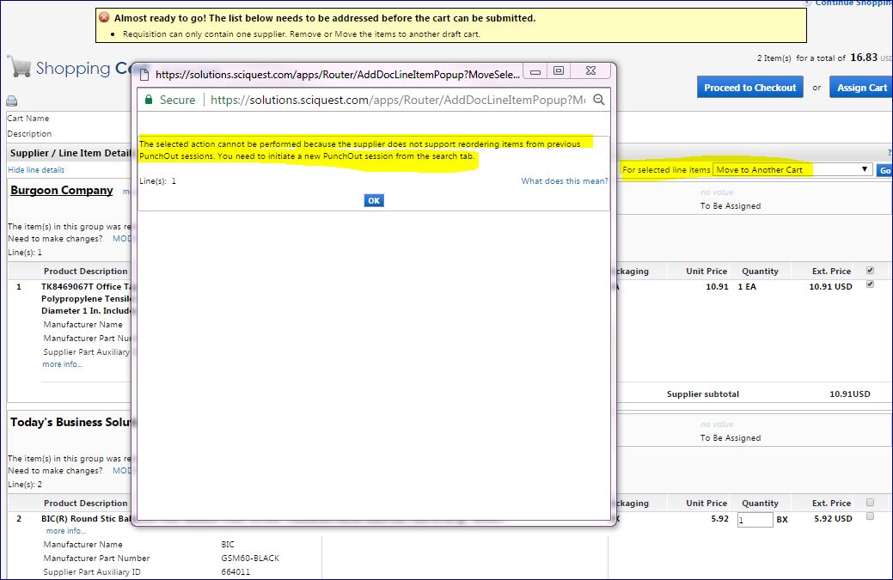

Assigning a Cart

A Shopper must assign his/her cart to a Requester (an Administrative Assistant or other support staff member) for an order to actually be placed.

Once you have selected your items and are in the active cart:
- Click on the Assign Cart button.
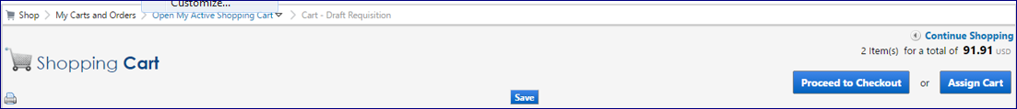

- Select the requester whom you would like to assign the cart by either:

  - clicking the Select from Profile Values radio button and selecting the appropriate name from the Select from profile values dropdown
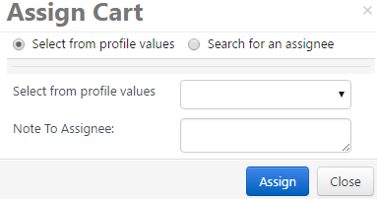

  - clicking the Search for an assignee radio button and click search for an assignee. 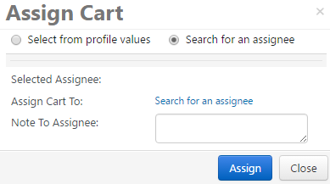

A “User Search” popup box will display, to add criteria (such as last name) and click the search button.
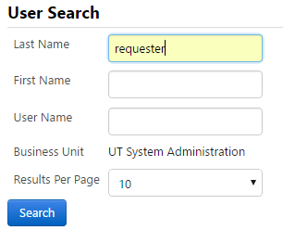

Click the select link for the appropriate name, to return to the original screen.
- Click the Assign button.

You will receive a confirmation that the cart was assigned successfully. Once assigned, the assignee receives an email notification.

Editing a Cart

Hosted vs. Punch-Out

Depending on what type of catalog an item is selected from, there are differences in how you can edit a cart in eSHOP. When adding items to the cart from a hosted catalog, you can edit these items in eSHOP directly from the cart.
Punch-Out items cannot be edited in the cart. You must Punch-Out to that catalog again. You do this by clicking the modify items link in the cart.
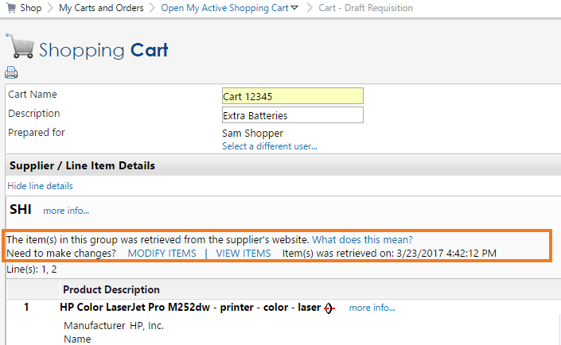

Carts that have been returned to UT Share/PeopleSoft

Once a cart becomes a UT Share/PeopleSoft requisition, the eSHOP cart is no longer editable.

If the order must be changed or corrected, it is recommended a Requester cancel the requisition and create a new cart in eSHOP, making the necessary changes. If the cart was assigned, the Requestor will need to notify the Shopper that the cart number has changed.

eSHOP Invoices

Invoicing in eSHOP is an automated process for eSHOP purchase orders. The vendor electronically sends an Invoice directly to UT Share/PeopleSoft.

After the goods have been manually Received in UT Share/PeopleSoft, the Voucher will automatically be created. If there are no Budget Checking errors and no Matching errors, the Voucher will automatically be approved.

Document Search

To look up any documents you have completed use the Document Search function. Click on the Documents icon in the left-side navigation bar then select the type of search you are interested in.

Document Search provides the ability to search across carts, purchase orders and e-Invoices to view the document histories all at the same time. When doing this, users will be presented with search options that span across multiple document types. Document searches are used to not only tell about “past” orders, but to access carts in process to determine the status.

