eSHOP for Requesters Training Manual

**Table of Contents**

**Overview** 2

**Accessing eSHOP** 2

**Navigation** 4

**Creating a Cart** 5

Ordering from a Punch-Out Catalog 6

Ordering from a Hosted Catalog 7

Co-Mingled Carts 7

**Completing a Cart** 8

Multiple Vendor Carts - Deleting More Than One ……………………………………………………………………………….8

Carts Assigned to Me ……………………………………………………………………………………………………………………..…11

**Editing a Cart** 14

Hosted vs. Punch-out 14

Carts that have been returned to UT Share/PeopleSoft 14

**eSHOP Invoices** 15

**Document Search** 16

# **Overview**

eSHOP is a role based shopping tool that allows users to take advantage of pre-negotiated contracts from well-known suppliers. As a requester, you are responsible for creating, reviewing, editing and submitting carts to become formal requisitions for approval in UT Share/PeopleSoft.

Requesters are users who have the authority to create requisitions in UT Share/PeopleSoft.

# **Accessing eSHOP**

If a user has a requester role, they will access the eSHOP from a link within UT Share/PeopleSoft. Requesters login to UT Share/PeopleSoft and navigate to **Requisition**, where there will be a link to eSHOP under the web tab.

1. Login to UT Share/PeopleSoft
2. Navigate to create requisition (**Navigation: Main Menu > eProcurement > Requisition**)

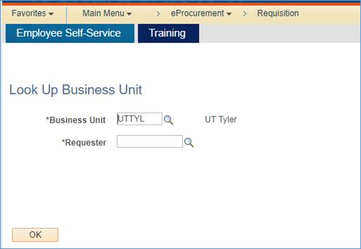

1. Enter Business Unit or Accept Default
2. Enter Requester
3. Click OK

On the resulting screen:

1. Click on **Request Options drop down box**
2. Click **Web** tab link
3. Punch-out to eSHOP by clicking **eSHOP Portal** link

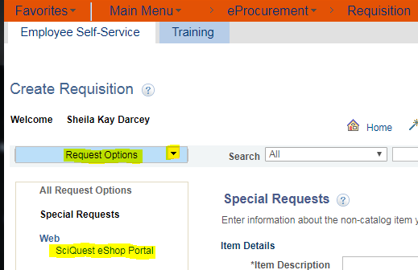

# **Navigation**

There are three main areas of the eSHOP screen:

1. The Main Workspace - The main workspace is where one can manage the active eSHOP feature. It will always display breadcrumbs that tell the navigation path to the page the user is accessing.
2. The side Navigation Menu - Most areas of eSHOP can be accessed from the side navigation menu. When a user rolls over the main menu icons, slide‐out sub‐menus display. In general, menus are grouped by related tasks. For example, shopping tasks are grouped in the **Shop** menu.
3. The Top Banner - The top banner contains access points to the user profile, bookmarks, assigned actions items and available notifications. In addition, users can access a quick view of their active shoppng cart and perform a quick search of the site.

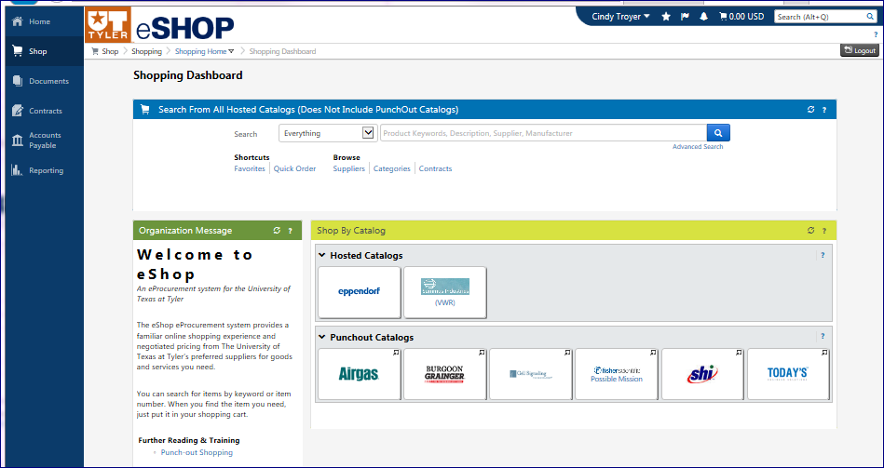

# **Creating a Cart**

There are two ways to shop in eSHOP:

1. Punch-Out Catalog: A Punch-out is a website where the shopper is redirected to the supplier’s site. A cart is created on that site. Then the shopper is redirected back to eSHOP with their selected merchandise.
2. Hosted Catalog: A Hosted Catalog is a supplier catalog that is embedded in eSHOP. The catalog is hosted by eSHOP, and can be searched by various criteria. Users can search for an item across all hosted suppliers, allowing users to comparison shop.

When comparative shopping your results will come from among hosted catalogs, not punch outs.

Users will create a cart in eSHOP using one of these methods. They can have multiple carts in process at the same time. To access your carts, click on the **Shop** menu, from the slide out menu select **My Carts and Orders**, and click **View Draft Shopping Carts**.

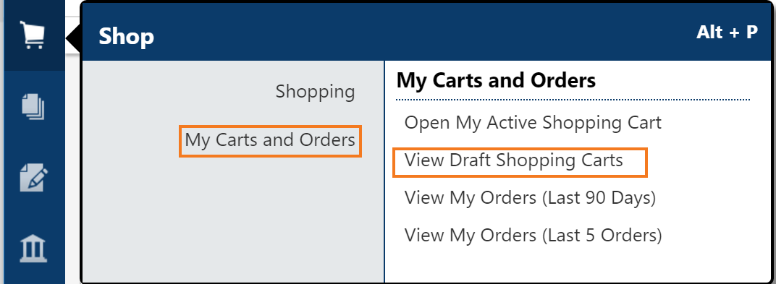

To create a new cart, click on the “**create cart**” button or simply start choosing items when searching and they will be added to an active cart that will show a summary in your top banner.

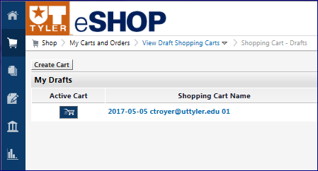

It is very important to remember to select from one vendor catalog at a time and complete the process entirely with that vendor.

Since a cart may eventually become a UT Tyler requisition and purchase order, the rule to remember is **One Cart – One Vendor – One Requisition**. *

## Ordering from a Punch-Out Catalog

Punch-out catalogs are external links to a supplier’s website. Click on the Vendor Icon in the Punch-out Catalog section of the Shopping Dashboard. This will take you to the vendor’s website for UT Tyler.

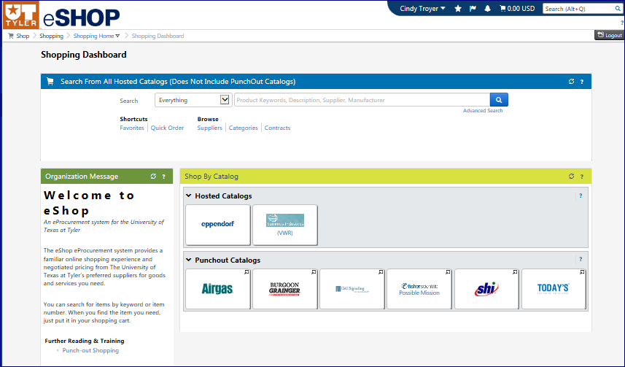

*Note*: Each vendor’s website will be specific to that vendor. Follow the directions on each website to search, select and order products. Each vendor will have some form of checkout that enables users to return to eSHOP. The Shopping Cart Page will appear when you return to eSHOP.

## Ordering from a Hosted Catalog

1. Search for items in the hosted catalog by using the simple search displayed below or by clicking on the advanced search.

Example: Battery 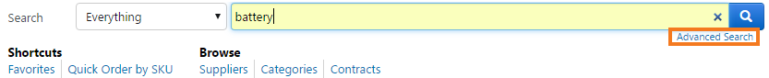

Search results can be sorted by price, supplier, part number, etc. Choose the sort method using the **Sort by** dropdown. Users can also filter results by keyword, product flag, supplier, category, packaging, etc. 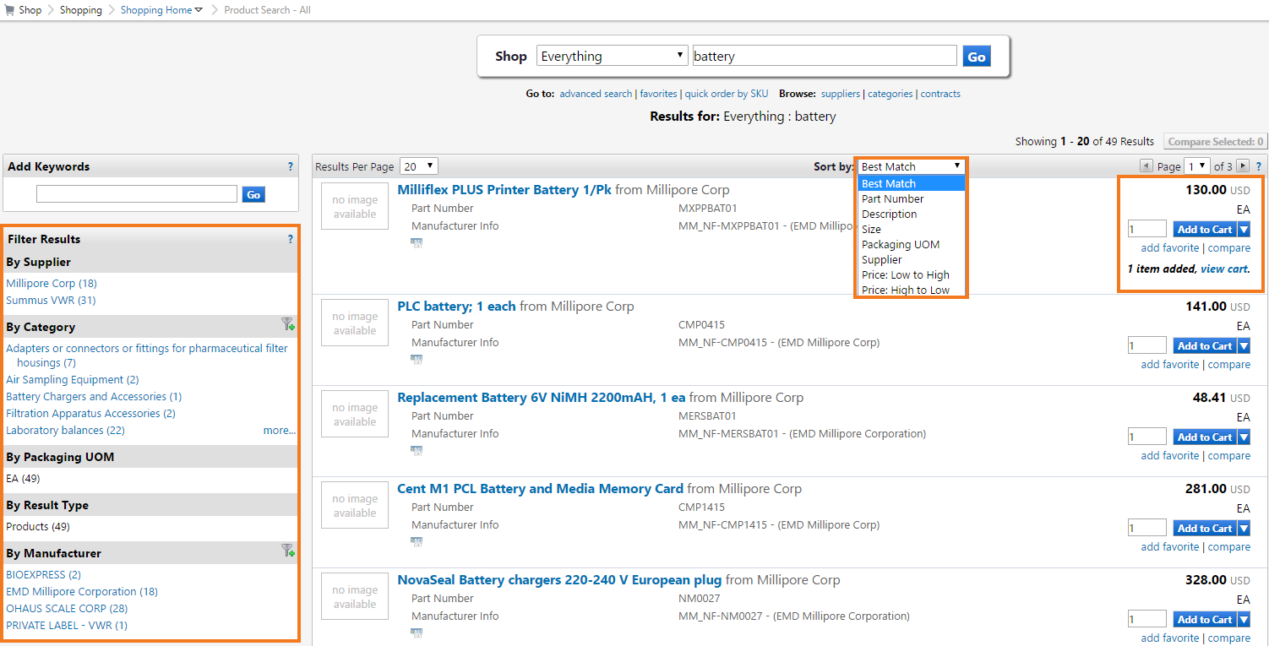

1. Change the quantity if needed.
2. Click the **Add to Cart** button.
3. Click **View Cart** to proceed.

## 

## Co-Mingled Carts

While eSHOP does allow you to enter items from more than one vendor supplier in the same cart, a co-mingled cart cannot be processed into a Requisition.

# **Completing a Cart**

While viewing a cart, users can name the cart for future reference or future searches. They can also modify the cart, empty the cart or take various other actions by using the dropdown. If you make changes, click the **Save** button. Requesters can submit their orders or orders assigned to them by a shopper for processing UT Share/PeopleSoft and for budget authority approval.

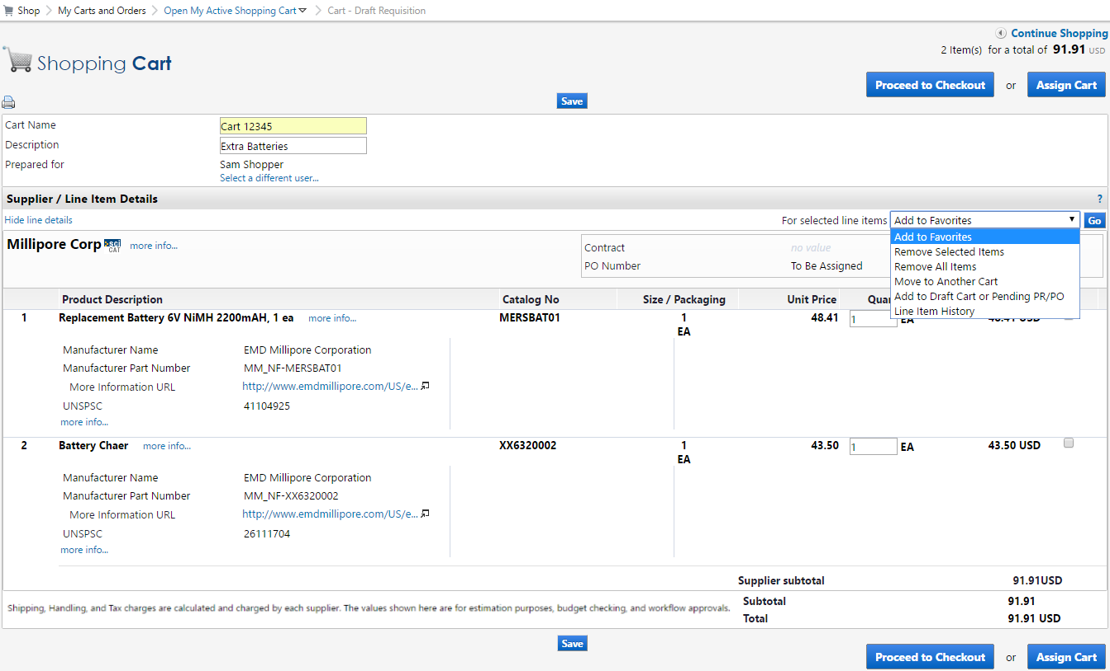

*Remember the rule from page 4 - **One Cart – One Vendor – One Requisition**?

If you or your Shopper inadvertently did select from more than one vendor during the shopping experience and before processing the cart through UT Share/PeopleSoft, you can fix the problem by deleting all but ONE vendor from your unprocessed cart.

Return the cart to the Shopper for him/her to Delete all but ONE of the vendors from the unprocessed cart.

* Select **Return Cart.**

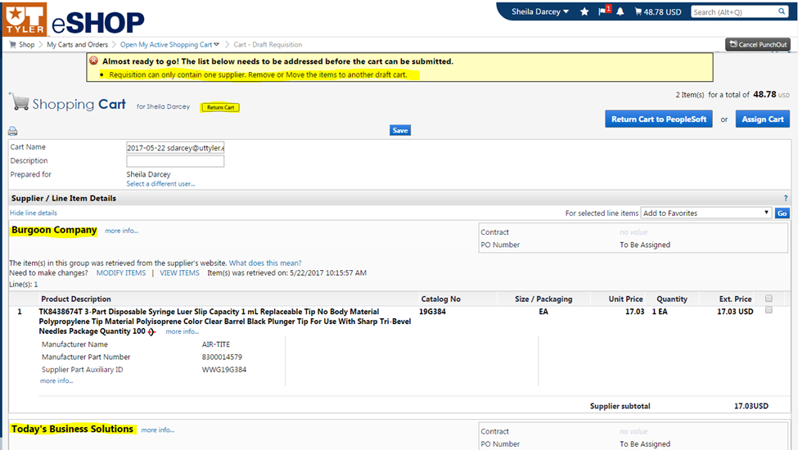

* Make a note why the cart is being returned to the Shopper.
* Click the **Return** button.

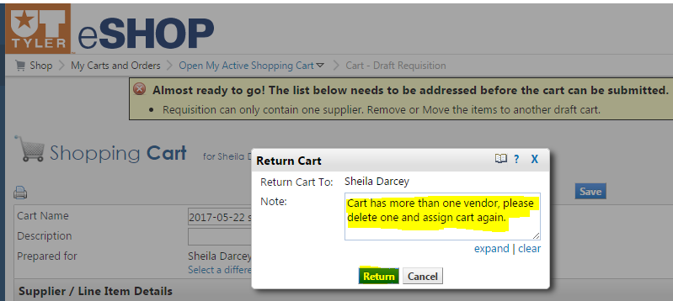

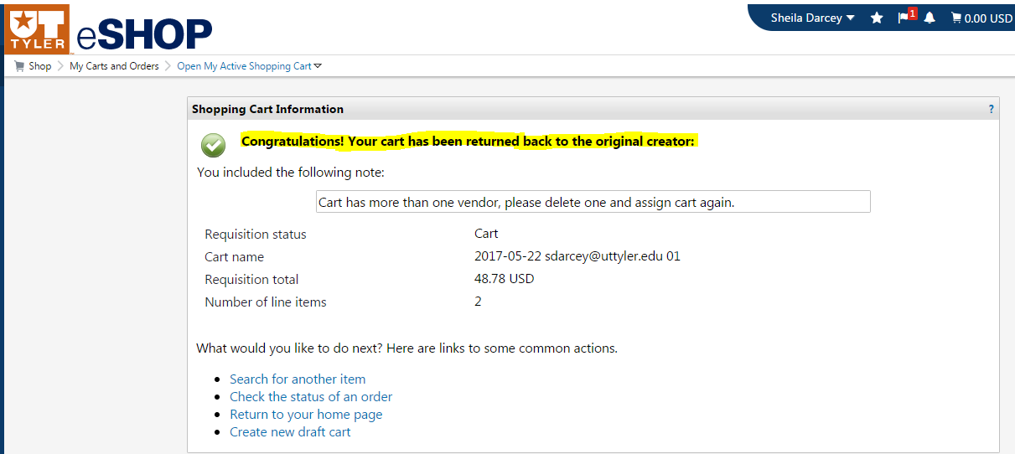

Or, the Requester can delete all but one of the vendors from the unprocessed cart.

* Select the vendor you want to delete.
* Select **Remove Selected Items** in drop down box.
* Click the **Go** button.

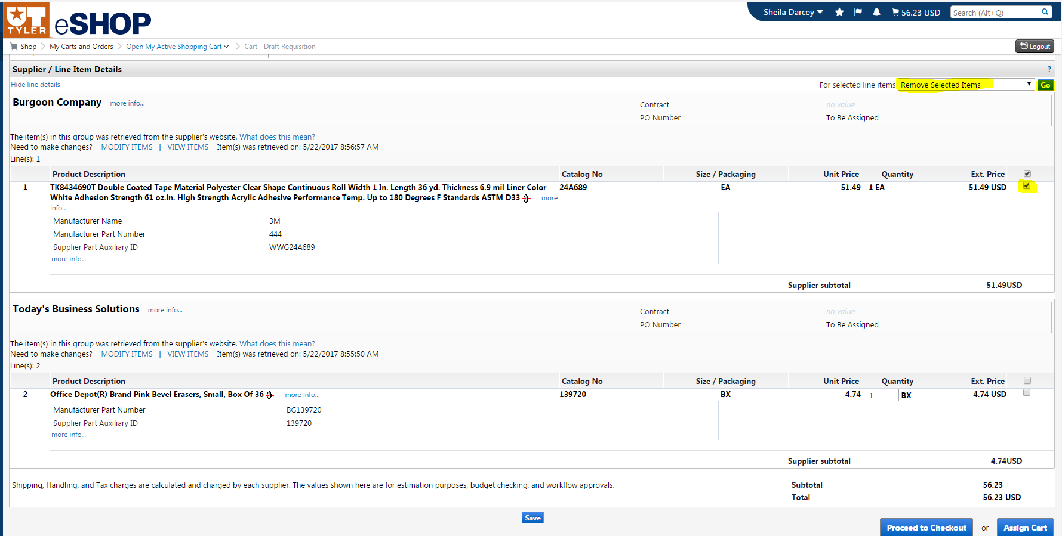

* Click the **Save** button.
* Then click the  **Return Cart to PeopleSoft** button.

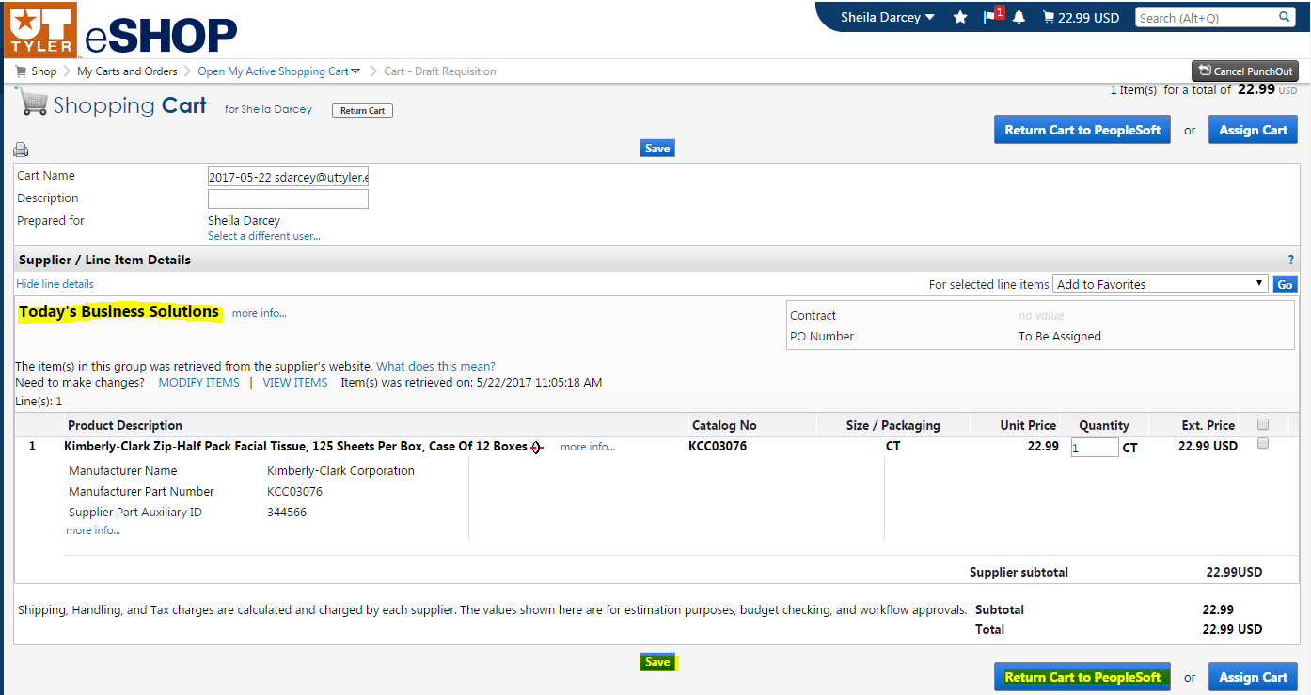

## Carts Assigned to Me

Shoppers use the assign cart function to submit orders for review, completion, and validation.

1. Once the shopper’s cart is submitted, the requester should receive an email if the notification listed above is enabled. There are three ways that a requester can find about any orders requiring review:
   1. Click on the **Action Items** in the top banner and select **Carts assigned to me**. 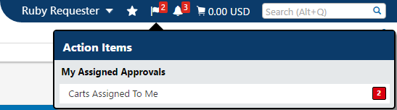
   2. 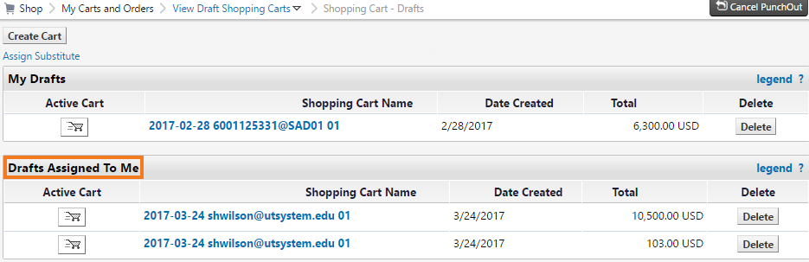Navigate to **Shop> My Carts and Orders > View Draft Shopping Carts**. A section on the page shows **Drafts Assigned to Me.**
   3. Click on the **Notifications** in the top banner and select a notification. 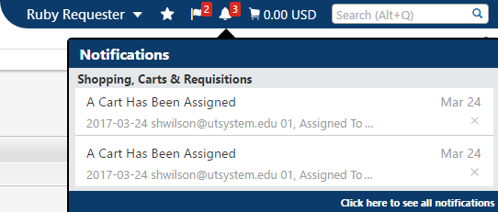
2. Click on the shopping cart name to review the order. Once all required fields are completed and the order reviewed, it can be Returned to UT Share/PeopleSoft. Standard cart changes – such as removing and adding line items, and changing quantities is allowed.
3. The requestor can now **Return the Cart for UT Share/PeopleSoft** processing. Also, the requester has the option to **Return Cart** back to the shopper. This is important if you need more information from the shopper. The two “Return Cart” buttons have been highlighted below.

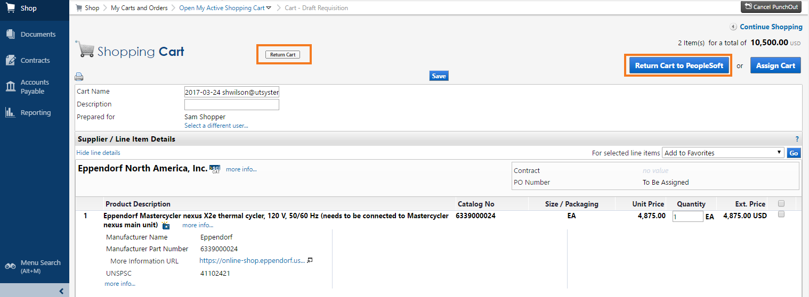

# **Editing a Cart**

## Hosted vs. Punch-Out

Depending on what type of catalog an item is selected from, there are differences in how you can edit a cart in eSHOP. When adding items to the cart from a hosted catalog, you can edit these items in eSHOP directly from the cart.

Punch-Out items cannot be edited in the cart. You must punch out to that catalog again. You do this by clicking the **modify items** link in the cart.

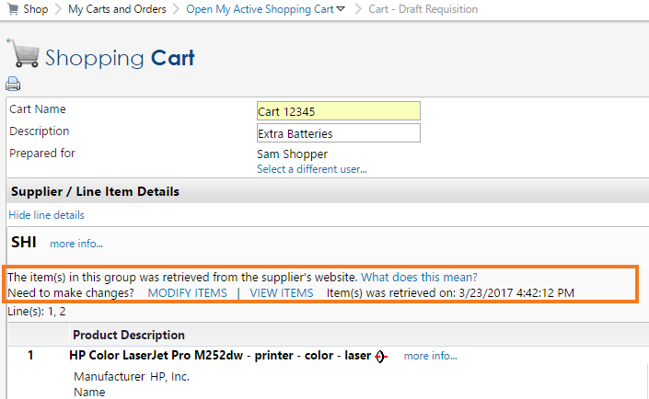

## 

## Carts that have been returned to UT Share/PeopleSoft

Once a cart becomes a UT Share/PeopleSoft Requisition, the eSHOP cart is no longer editable.

If the order must be changed or corrected, it is recommended that the Requester cancel the requisition and recreate it in eSHOP, making the necessary changes. If the cart was assigned, the Requestor will need to notify the Shopper that the cart number has changed.

# **eSHOP Invoices**

Invoicing in eSHOP is an automated process for eSHOP purchase orders. The vendor electronically sends an Invoice directly to UT Share/PeopleSoft.

After the goods have been manually Received in UT Share/PeopleSoft, the Voucher will automatically be created. If there are no Budget Checking errors and no Matching errors, the Voucher will automatically be approved.

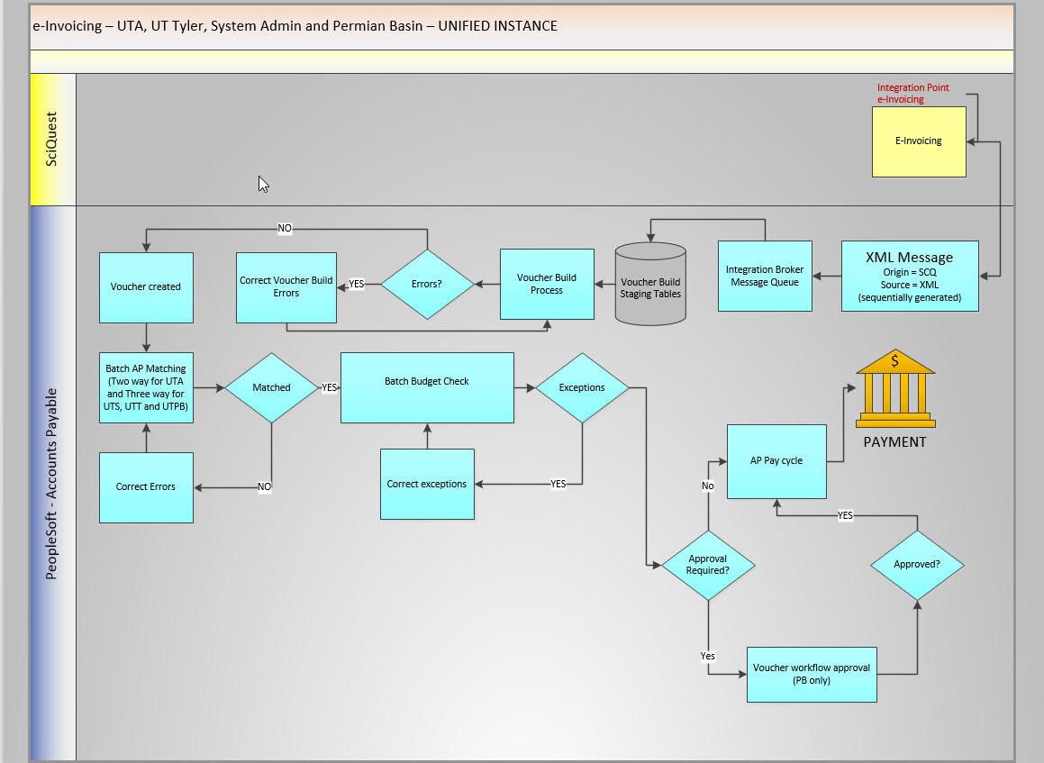

# **Document Search**

To look up any documents you have completed use the **Document Search** function. Click on the **Documents** icon in the left-side navigation bar then select the type of search you are interested in.

**Document Search** provides the ability to search across carts, purchase orders and e-Invoices to view the document histories all at the same time. When doing this, users will be presented with search options that span across multiple document types. Document searches are used to not only tell about “past” orders, but to access carts in process to determine the status.

