eSHOP Navigation

Table of Contents
Overview 2
Side Navigation 3
Home 3
Shop 3
Shopping 3
My Carts and Orders 3
Documents 4
Document Search 4
Contracts 4
Contracts 4
Reporting 4
Supplier Management 4
Main Workspace 5
Top Banner 6
Profile 6
Bookmarks 6
Action Items 6
Notifications 7
Active Shopping Cart 7
Quick Search 7

Overview
There are three sections which will always be accessible on the screen as tasks are performed.
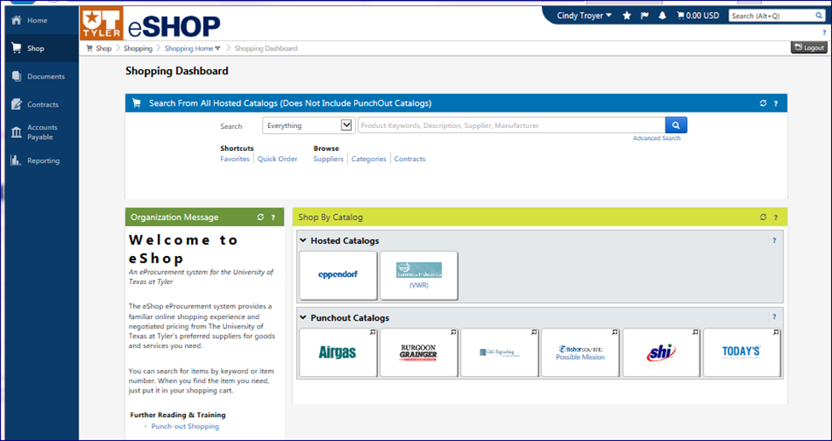

- Side Navigation Menu
- Main Workspace – Breadcrumbs show what page is being accessed in the Main Workspace.
- Top Banner

Side Navigation
Side Navigation sections are available based on a user’s permissions.

Home
Navigates to a user’s dedicated homepage.
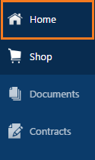

Shop

Shopping
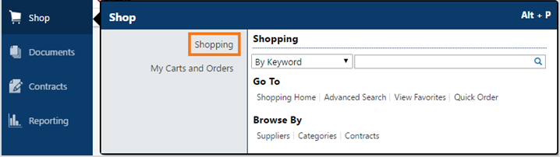
Menu includes a product search bar, quick links to the shopping dashboard, advanced search, favorites and quick order menu. Also, gives users the option to browse by Supplier, Category or Contract.

My Carts and Orders
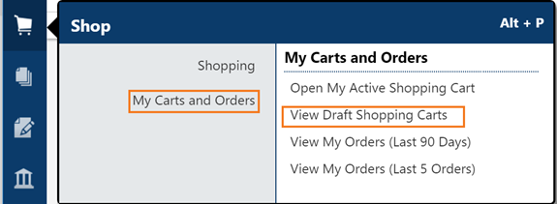
Allows users to manage carts and view past orders.

Documents

Document Search
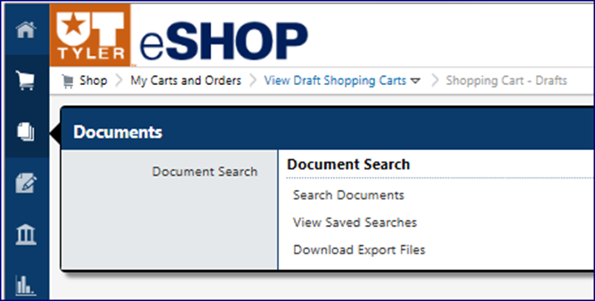
Allows users to search through documents such as carts and view document searches they have saved.

Contracts

Contracts
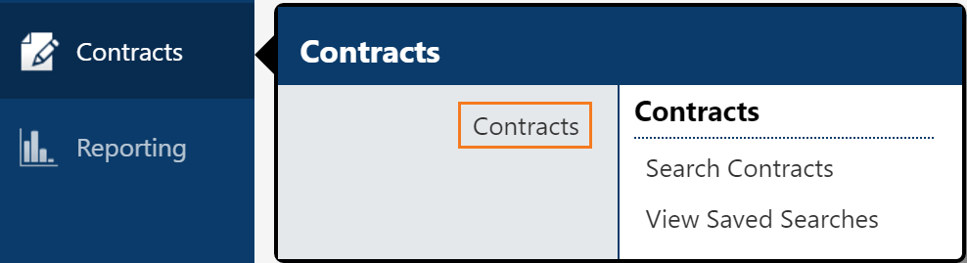
Allows users to search through contracts uploaded into eSHOP and view contract searches they have saved.

Reporting

Supplier Management
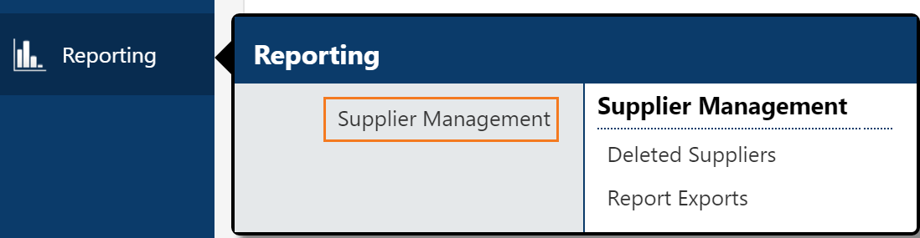
Allows users to create and view delivered reports such as deleted suppliers.

Main Workspace

The main workspace is where one can view and manage the active eSHOP feature. As a user accesses other areas of eSHOP only the main workspace changes and the side navigation menu and top banner remain in place. As you navigate through eSHOP, the ‘breadcrumbs’ will be displayed at the top of the screen.

You can click to view and navigate to other locations by using the drop down in the breadcrumbs.
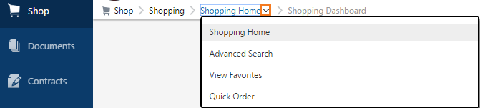

Top Banner

Profile
Click your name in the banner to display the View My Profile, Dashboard and Logout links. And also to set your Home Page.
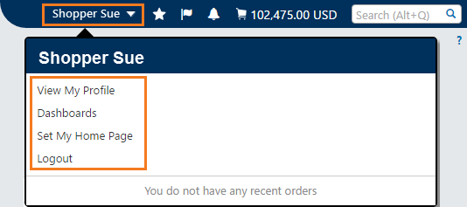

Bookmarks
Click the star icon in the banner to access the Bookmarks function. 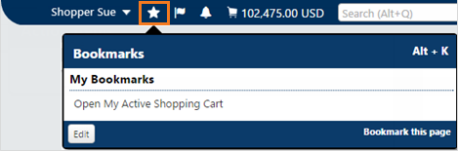
- You can move directly to a eSHOP page by clicking the selected bookmark.
- You can add the current eSHOP page to My Bookmarks by clicking Bookmark this page link.
- You can edit Bookmarks by clicking the Edit button.

Action Items
Click the flag icon to access the list of pending action items. The items in the list are clickable so users are taken to the appropriate page to complete the action.
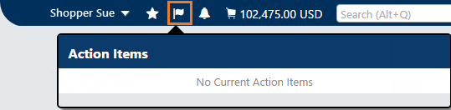

Notifications
Notifications are available in the top banner and/or via email. In your profile, you can designate how and when you receive notifications, via the eSHOP Top Banner, email or both.
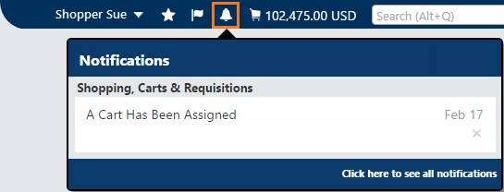

Active Shopping Cart
Click on the shopping cart icon to preview the active shopping cart. 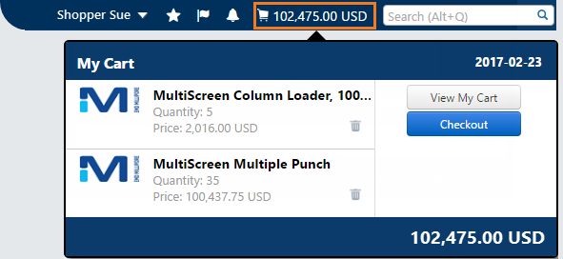
- The View My Cart button takes you to the active shopping cart.
- The Checkout button takes you to the final review screen.

Quick Search
Click the magnifying glass icon to access Quick Search.
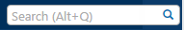
The Quick Search feature allows a variety of searches, such as supplier profile, user profile and document.

