Navigation

9.2 Navigation
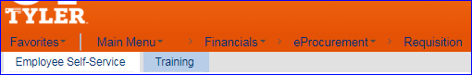
The menu item labeled “Create Requisition in 9.1 is now labeled “Requisition” in 9.2.

Creating Requisition
The create requisition has a completely different look. It will complete the same functions with new added features. The

Create Requisition Home Page
Below is the new look of the Requisition Home Page.
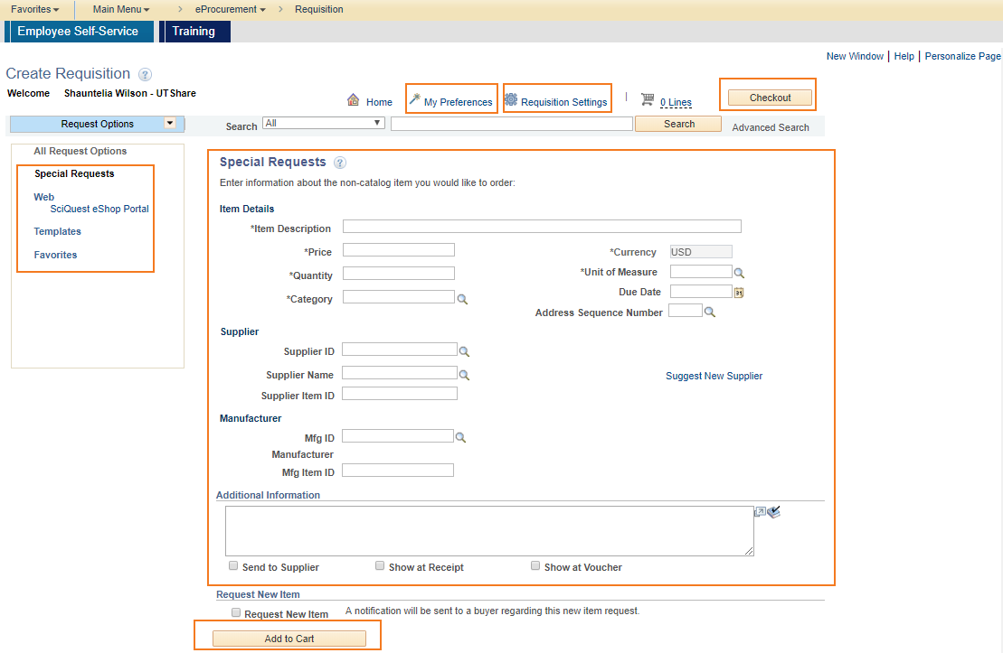

Requisition Settings
The Define requisition tab is now the Requisition Settings link. The default lines pull down is now part of the screen as its own section. You can name your requisition here (as well as at checkout) and that field is now on the upper right side of the screen.
As you see on the screenshot here and throughout PeopleSoft 9.2 Vendor is now referred to as Supplier.
Supplier Location is now under Supplier; it was previously to the right. Unit of Measure is now located under the Category field, removing the 3rd column in the line defaults section.
Modify One time Address link has been renamed with Add One Time Address
NOTE: Best practice is to use Requistion Settings for Special requisitions only as most default information in eShop will come from the cart and cannot be altered without causing errors. You can enter SpeedChart information with the Mass Change Feature on the Checkout - Review and Submit Page as well as enter Requisition Name on the Checkout page.
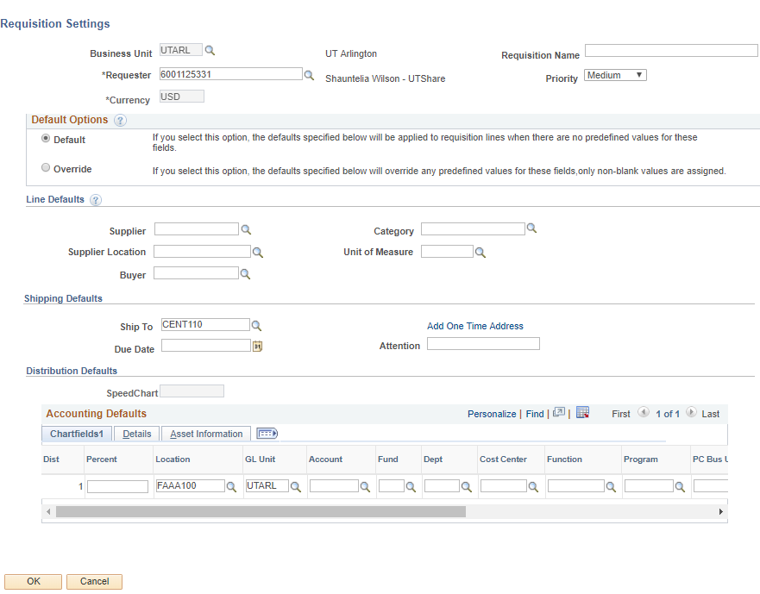

Request Options
Requisition options houses your eShop Portal link and any templates or favorites you have saved. You must click the down arrow to expand and access these options. This eShop portal works the same as it has in 9.1. You punchout to eShop and shop. You then with either assign or return your cart to PeopleSoft just as you did in 9.1. You will end on the Checkout - Review and Submit page where you can enter your SpeedChart, Ship to, comments and other important information.

My Preferences
My Preferences for Requisition opens as a window to select the fields to display in a search result. You can also choose to auto expand accounting lines when you expand a requisition line (which saves you an extra click) and auto display the shopping cart as you add items.
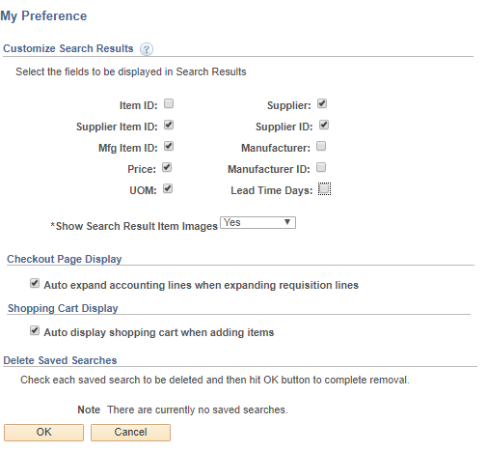

Requisition Settings
Use the Requisition settings link to Name the Requisition as well as define requisition defaults, including Supplier, Category, and more. For SpeedChart entry, be sure to check the Override button at the top under Default Options.
NOTE: Best practice is to use Requistion Settings for Special requisitions only as most default information in eShop will come from the cart and cannot be altered without causing errors. You can enter SpeedChart information with the Mass Change Feature on the Checkout - Review and Submit Page as well as enter Requisition Name on the Checkout page.

D. Special Requests
Use the Special Request page to create requisitions for items or goods. Your defaults from the Requisition Settings link will be here if you entered them prior to starting your requisition.
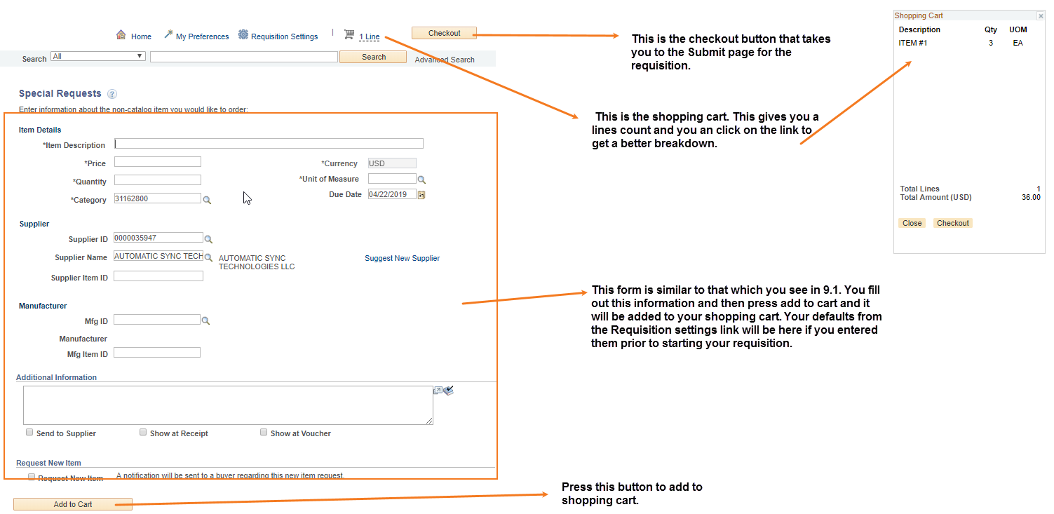
The special request form requires the same information as required in 9.1. Fill out the form with the needed information and press the Add to Cart button at the bottom of the screen. This will add the item to your shopping cart. You can then add another item or Checkout if you are finished. As in 9.1, the supplier information is ‘frozen’ to keep the same supplier on all lines. If you need a different ordering address than the one shown, you should choose it on your first line and it will ‘freeze’ for the rest of line entries.
The Shopping Cart is a link and cart icon at the top middle of the page. You can also see your shopping cart summary to the right of the page if you chose this in My Preferences. Either place gives you an item count.
You will click the Checkout button to take you to the submit page for the requisition (previously the Review and Submit tab from 9.1).

Submitting Requisition
When you finish adding items, you will click on Checkout; either at the top of the page or in the Shopping Cart to the right. You can save the requisition and submit it for approval immediately or save for later. Apart from editing the requisition, you can add comments and attachments to them as well.

Checkout – Review and Submit
The fields are generally the same for the Checkout – Review and Submit Page as 9.1 Save and Submit tab. There are some additions highlighted below.
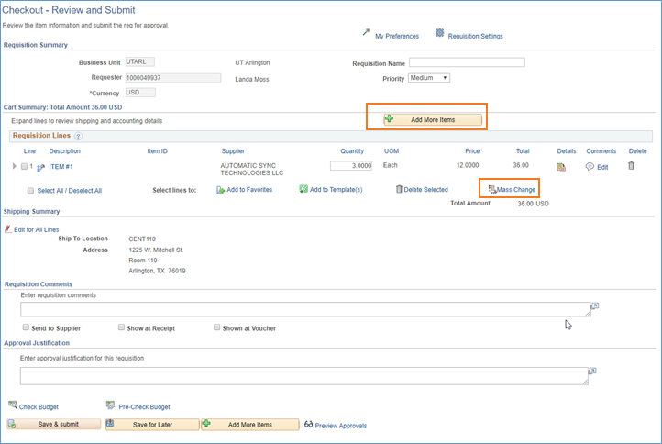
- Add More Items - Click this to reach the Create Requisition screen to add more items. NOTE: Items should not be added to eShop requisitions.
- Requisition Comments and Approval Justification are now separate comment boxes in 9.2.

- Mass Change - Click to access the Edit Lines/Shipping/Accounting details for selected lines, where you can change the shipping location, delivery date, and so on. You can also change the Accounting Lines (speedchart, etc.) for the selected requisition lines.
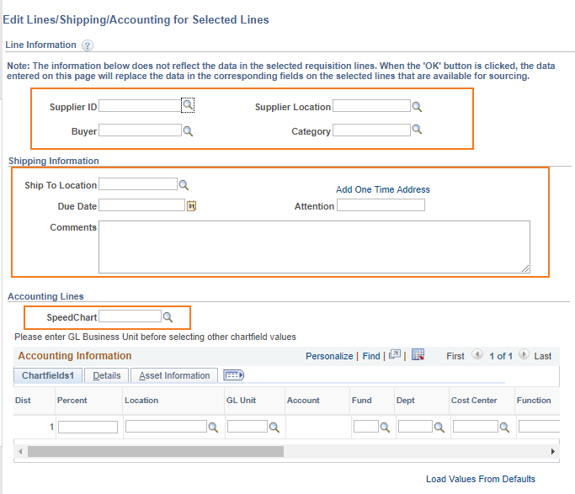
Once you have reviewed your requisition there is a new option to Save for Later. You can also Check Budget, Save and Submit into workflow, and/or Preview Approvals as in 9.1.

