Request to Add/Change a Cost Center,
Department, and/or Budget Authority in PeopleSoft
Contents
How to Create a New Cost Center 2
How to Change an Existing Cost Center’s Attributes 4
a. Changing Cost Center’s Title: 4
b. Changing Cost Center’s Department: 4
c. Changing the function of a Cost Center: 4
How to Create a New Department 6
How to Change an Existing Department’s Attributes 7
a. Changing the Department’s Title: 7
b. Changing the Department’s Budget Authority: 7

How to Create a New Cost Center
- Follow the link for the Add/Change Form.
- At the top of the form, specify the date you would like for the new cost center to become effective. The format must be XX/XX/XXXX (Ex. 01/01/2015). Then, input the budget authority’s username in the “New Bud Auth Username” section. (This will be in the format of the UT System login. i.e. “jbrown”,”ssmith”.) Please note that the correct username is crucial for the successful routing of this form!
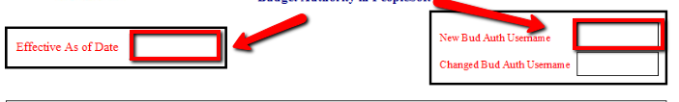
- Check the “New” box next to Cost Center Request. In the “New Cost Center Title Box”, you will specify the title of your cost center. (There is a letter limit for this field in PeopleSoft, therefore the title might be shortened as necessary). Next, specify the “Fund Code” and the “Function” from the drop down lists. If you are unsure of either of these, the budget office will make the determination for you. 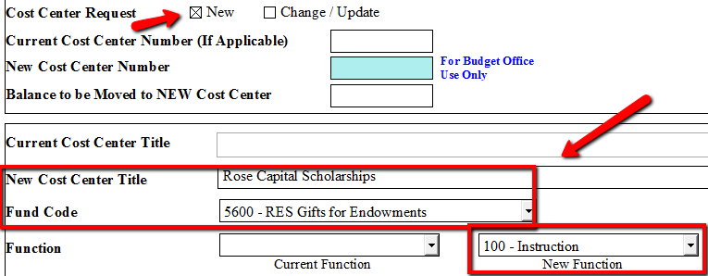
- Next, you will need to specify if this cost center will be under a new department/budget authority or an existing one. If this will be a new department, proceed to step A. If this will be using an existing department, proceed to step B.
  - NEW Department. Check the “New” box next to Department. Specify the new department’s title in the “New Department Title” box. Then, specify the new budget authority’s employee id “i.e. 5000123456”, and the new budget authority’s first and last name. Last, specify which department this new department will report to. 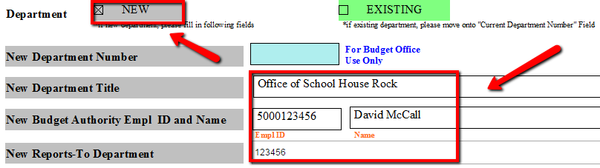
  - EXISTING Department. Check the “Existing” box next to the department. Fill in the “Current Department Number” and the “Current Department Title”. Then, specify the current budget authority’s employee id “i.e. 5000123456”, and the current budget authority’s first and last name. Last, specify which department this new department will report to in the “Current Reports-To Department Number” box.
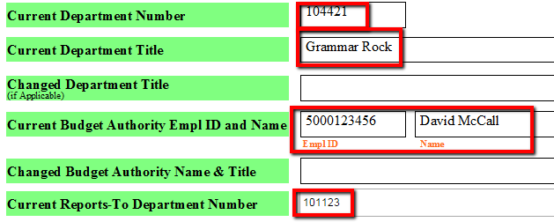
- Review your inputted information and verify that everything is correct. Then, click on “Next Page” in the bottom right hand corner of the form.
- Fill out the three remaining text boxes with the sources of the funds that will be depositing into the cost center, explain how the funds will be used, and specify any other pertinent information that might be useful or relevant.
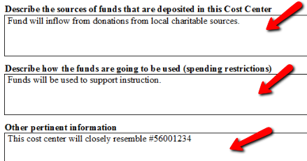
- Lastly, fill out the requestor name box (the person filling out the form), specify the requested date (format must be XX/XX/XXXX), and click “Submit”. The form will then be routed to the budget authority that you specified in step 1 for approval.
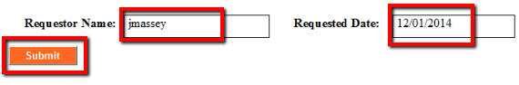

How to Change an Existing Cost Center’s Attributes
- Follow the link for the Add/Change Form.
- At the top of the form, specify the date you would like for the cost center changes to become effective. The format must be XX/XX/XXXX (Ex. 01/01/2015). Then, input the budget authority’s username of the cost center in the “New Bud Auth Username” section. (This will be in the format of the UT System login. i.e. “jbrown”,”ssmith”.) Please note that the correct username is crucial for the successful routing of this form!
- Check the “Change/Update” box next to Cost Center Request, and fill out the “Current Cost Center Number” box.
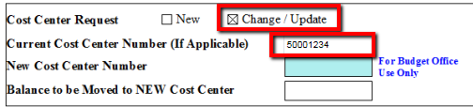
- Next, specify the attribute of the cost center that you are wanting to change:
  - Changing Cost Center’s Title:
To change the Cost Center’s title, fill out the “Current/ New Cost Center Title” boxes appropriately.
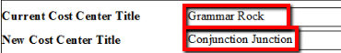
  - Changing Cost Center’s Department:
To change the department that a Cost Center falls under, there are a few fields that you will need to specify. First, you will need to specify the “Current Department Number” and the “Current Department Title”. Next, you will need to specify BOTH the new Department Number AND the Department’s title in the “Changed Department Title” box. Then, you will need to fill out the boxes for both the Current Budget Authority, and the New Budget Authority. Last, you will need to specify the current and the new “Reports To” box.
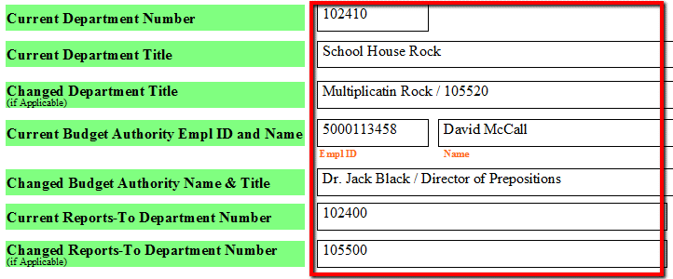
  - Changing the function of a Cost Center:
To change the function of the cost center, select the current function from the drop down list, as well as the new function.
- Review your inputted information and verify that everything is correct. Then, click on “Next Page” in the bottom right hand corner of the form.
- Fill out the “Other pertinent information” box, and specify the changes that you have made.
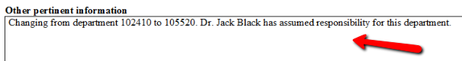
- Lastly, fill out the requestor name box (the person filling out the form), specify the requested date (format must be XX/XX/XXXX), and click “Submit”. The form will then be routed to the budget authority that you specified in step 1 for approval.

How to Create a New Department
- Follow the link for the Add/Change Form.
- At the top of the form, specify the date you would like for the new department to become effective. The format must be XX/XX/XXXX (Ex. 01/01/2015). Then, input the budget authority’s username in the “New Bud Auth Username” section. (This will be in the format of the UT System login. i.e. “jbrown”,”ssmith”.) Please note that the correct username is crucial for the successful routing of this form!
- Check the “New” box next to Department. Specify the new department’s title in the “New Department Title” box. Then, specify the new budget authority’s employee id “i.e. 5000123456”, and the new budget authority’s first and last name. Last, specify which department this new department will report to. 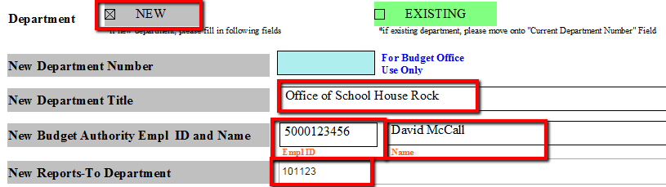
- Review your inputted information and verify that everything is correct. Then, click on “Next Page” in the bottom right hand corner of the form.
- Fill out the “Other pertinent information” box, and specify the information about the new department.
(ex. who will be the backup budget authority for this department)
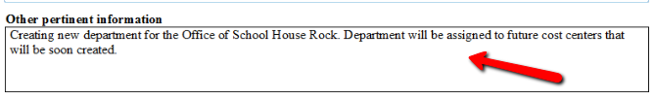
- Lastly, fill out the requestor name box (the person filling out the form), specify the requested date, and click “Submit”. The form will then be routed to the budget authority that you specified in step 1 for approval.

How to Change an Existing Department’s Attributes
- Follow the link for the Add/Change Form.
- At the top of the form, specify the date you would like for the department changes to become effective. The format must be XX/XX/XXXX (Ex. 01/01/2015). Then, input the budget authority’s username of the department in the “New Bud Auth Username” section. (This will be in the format of the UT System login. i.e. “jbrown”,”ssmith”.) Please note that the correct username is crucial for the successful routing of this form!
- Check the “Existing” box next to Department.
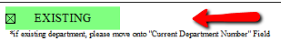
- Next, specify the attribute of the department that you are wanting to change:
  - Changing the Department’s Title:
To change the title of the department, you will need to specify the current department number, as well as the current title. Then, specify the new title in the “Changed Department Title” box. Last, specify the current budget authority’s name and employee ID number.
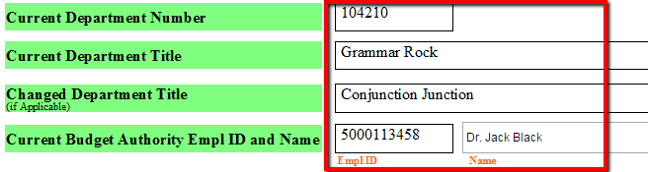
  - Changing the Department’s Budget Authority:
*This is to be used when the department number stays the same, but the budget authority of the department is changing*. To change the budget authority of the department, first specify the department number and title. Then, you will need to fill out the current budget authority’s information, as well as the new budget authority’s information (be sure to include the name, title, and employee ID # of the new budget authority). Last, specify the departments that the current budget authority and the new budget authority reports to.
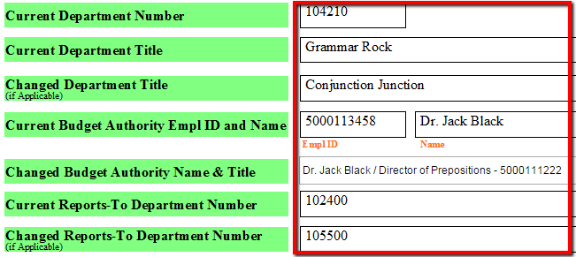
- Review your inputted information and verify that everything is correct. Then, click on “Next Page” in the bottom right hand corner of the form.
- Fill out the “Other pertinent information” box, and specify the information about the changes to the department. (ex. who will be the backup budget authority for this department)
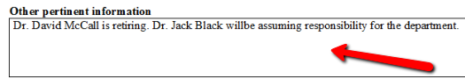
- Lastly, fill out the requestor name box (the person filling out the form), specify the requested date (format must be XX/XX/XXXX), and click “Submit”. The form will then be routed to the budget authority that you specified in step 1 for approval.

